Technical Report of Endangered Orbits

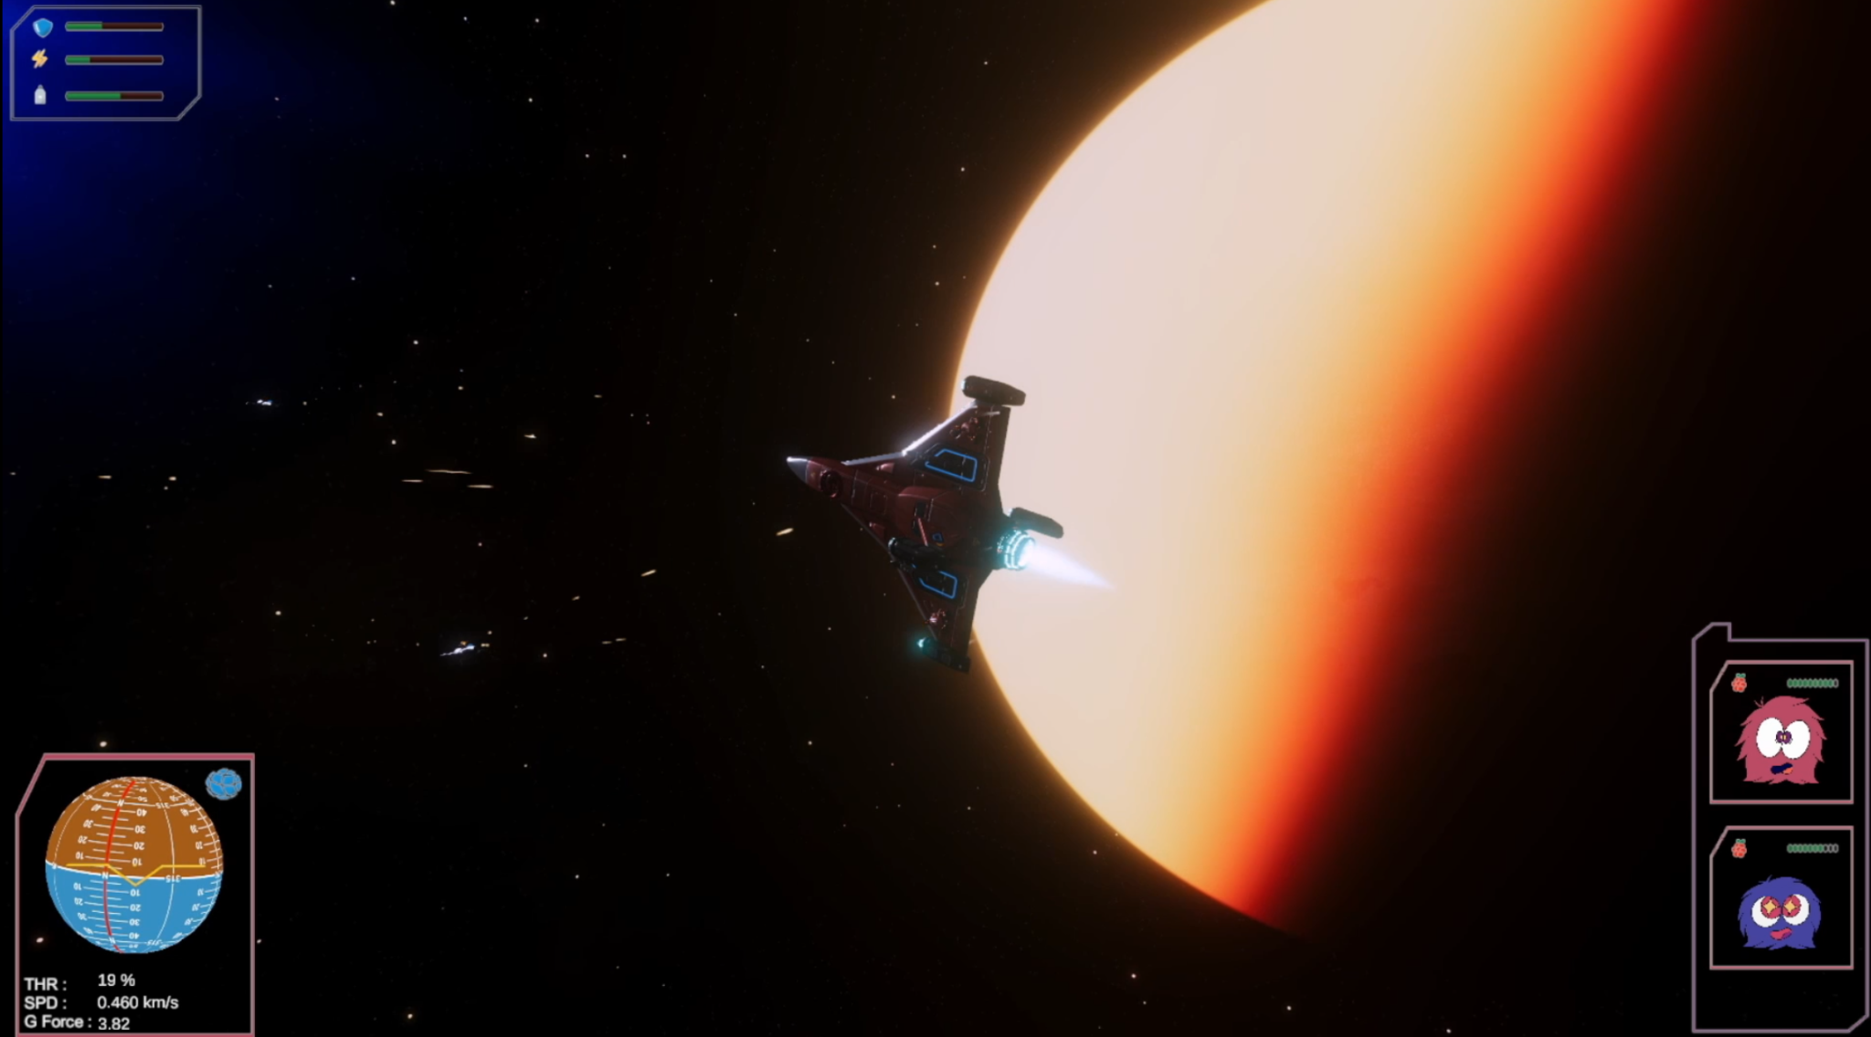

Contents
Contents 1

Introduction 3
Overview implementation 4
Scale of the planetary system 4
Scale of Objects 5
Realistic behavior of Spaceship 5
Control Of Spaceship 6
Modular Ship Construction 7
Pathfinding 8
Object Avoidance 8
Applying Movement 8

Math and Physics - Planetarium Module 11
State vector to Orbital Elements 22
N-Body integrator 27
Numerical Runge Kutta Methods 28
RK 4 Scheme 28
RK 8 Scheme 29
Heliocentric reference frame 30
RK4 Orbit prediction 31
Planetarium Floating Objects 32

Atmospheric Scattering 34
Mathematical model of the atmosphere 35
The Shader 35
The Vertex Shader 35
Rasterization 36
The Fragment Shader 36
Application for atmospheric scattering 37
Scattering Functions 37
The Math of Atmospheric scattering 39

Math and Physics - Ship Module 43
Spacecraft Axs 43
Reaction Control 45
Inertia Tensor - Rotation 45
Composite center of mass 48
Composite Inertia Tensor 49
Torque 51
Translational movement 52
Handling of position and rotation of gameobject 53

Crafting Dynamic Spaceships and Paths 56
Modular Ship Construction 56
The Goal 56
Defining Modules 56
Attachment Points 60
Control 62
Pathfinding 63
It’s Raycasts All the Way Down. 64
Object Avoidance 66
Movement 68

Introduction
By Jacob Tang
The overarching goal of this project is to familiarize with the math and physics aspect of game design, where it governs how objects in a game scene moves and rotates upon the framework of a space simulation game. This is an attempt to demonstrate and bridge the gap between a Computer science major and an informational technology major, the “math” part. Hence endangered orbit's foremost emphasis is on realistic physics, which implements the real scale to those found in the cosmos resulting in a level of depth shall be deeper in many ways compared to the kerbal space program, in the regime of spacecraft movement physics as well as orbital mechanics. The next focus of the game shall be graphical fidelity, involving implementation of mathematical compute shaders that run natively on the GPU as post processing techniques, basically similar to “ray tracing”.
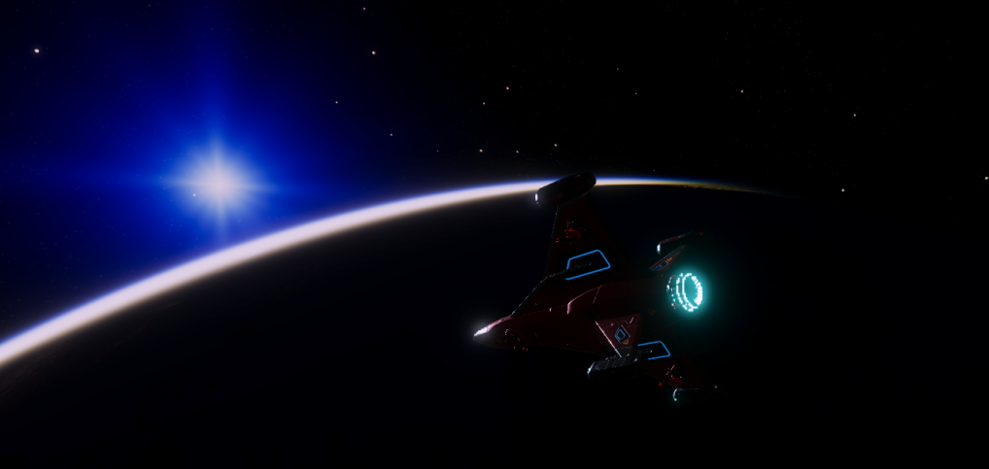
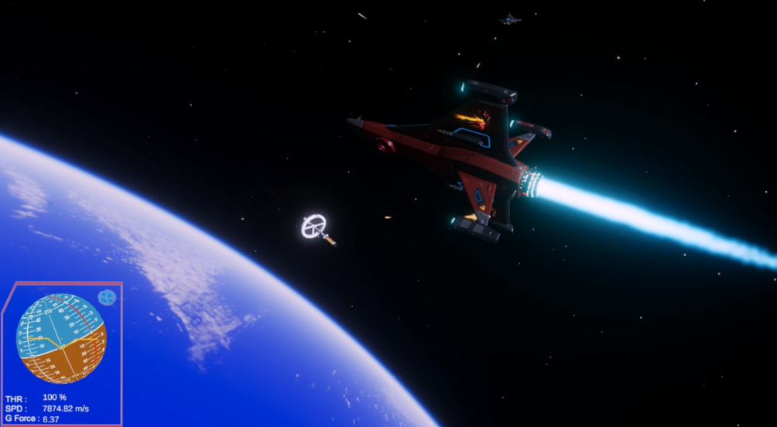
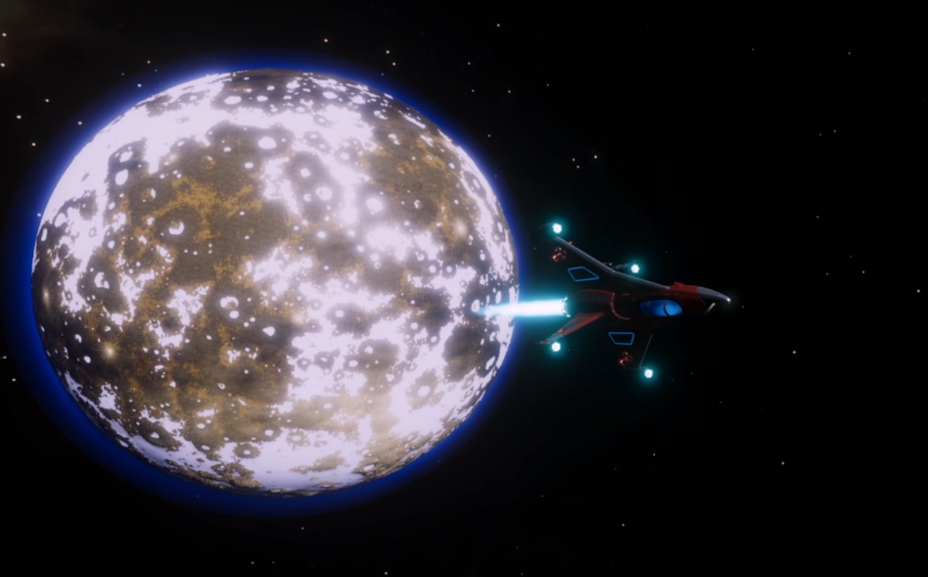
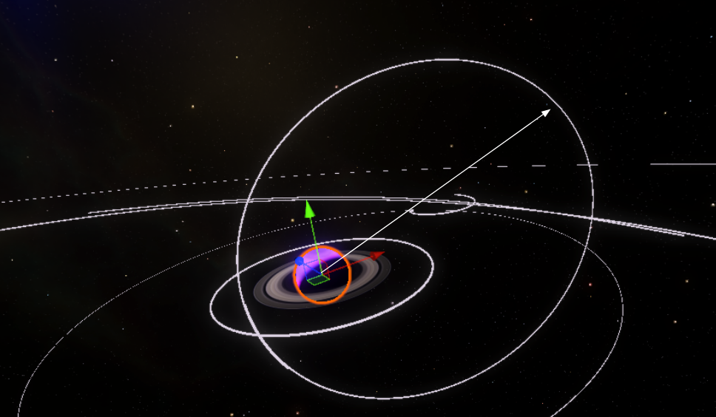

Overview implementation

Scale of the planetary system

There are several constraints that arise from the decision above when developmenting in unity. Unity is built as a cross platform game engine that has an emphasis on small to mid scale first person style combat or mobile games, hence the infrastructure is only meant for those games. In order to make it work as described above, significant modifications have to be made under the hood. Below are areas of challenges.

There are two types of scale, one being scale in terms of the pure distance between objects, where the average distance between planets is represented by millions of KM. Secondly the difference in scale of objects where a spaceship can be millions of times smaller in scale than a planetary body. Both these extremes are not supported by unity’s engine. Essentially the problem with unity is precision. Suppose if we want to represent the location of planets and spaceship over a distance over billions of kilometers, using unity’s object transform system, the object’s position being stored in single precision floating point number, we will find ourselves running out of precision, there aren’t enough precision to store the position of a ship. Additionally, the precision in gamespace is not evenly distributed, in unity, much more precision is given to objects closer to the game origin, while lower precision is given to objects further from the game origin. From testing, it seems that beyond 10,000 units or meters from the game origin, precision becomes insufficient. This has probably the greatest impact on unity’s rendering pipeline using vertex positions derived from a ship's position, resulting in errors from floating point rounding, causing vertex positions to jitter rapidly.

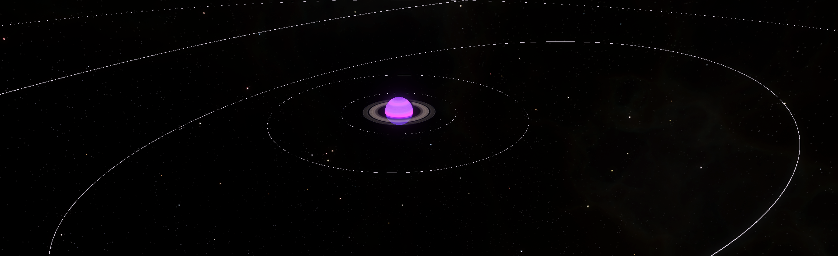

Scale of Objects

Object scaling is a major issue. If we want to have the spaceship in the same scene as the celestial bodies, we would need to scale a spaceship to millions of times smaller. This once again compounds to the fact that rendering pipeline shaders uses scaling to determine vertex positions, and causes significant jittering due to low precision. Additionally scale determines other properties related to rigid bodies like inertia where calculation is done assuming that one unit in game is 1 meter in real life.
Several methods are used to solve this issue of precision and scale. This is a 3 prong approach, which are double precision math, floating origin and separate scenes. This allows us to somewhat handle all physics, like position outside of the game, then with various transformations, we can transform game objects from world position (actual physical position) into editor position, where those objects can be scaled and rendered. Floating origin is another set of transformations that transforms the default cartesian grid to be playercentric, where the player is always in the center of the game origin; this would solve the unequal precision issue. Finally it is impossible to have all objects on the same scene, hence we shall need to use different scenes to render each component separately then composited together into the final game. This is important since perspective, the sense of scale is achieved here.

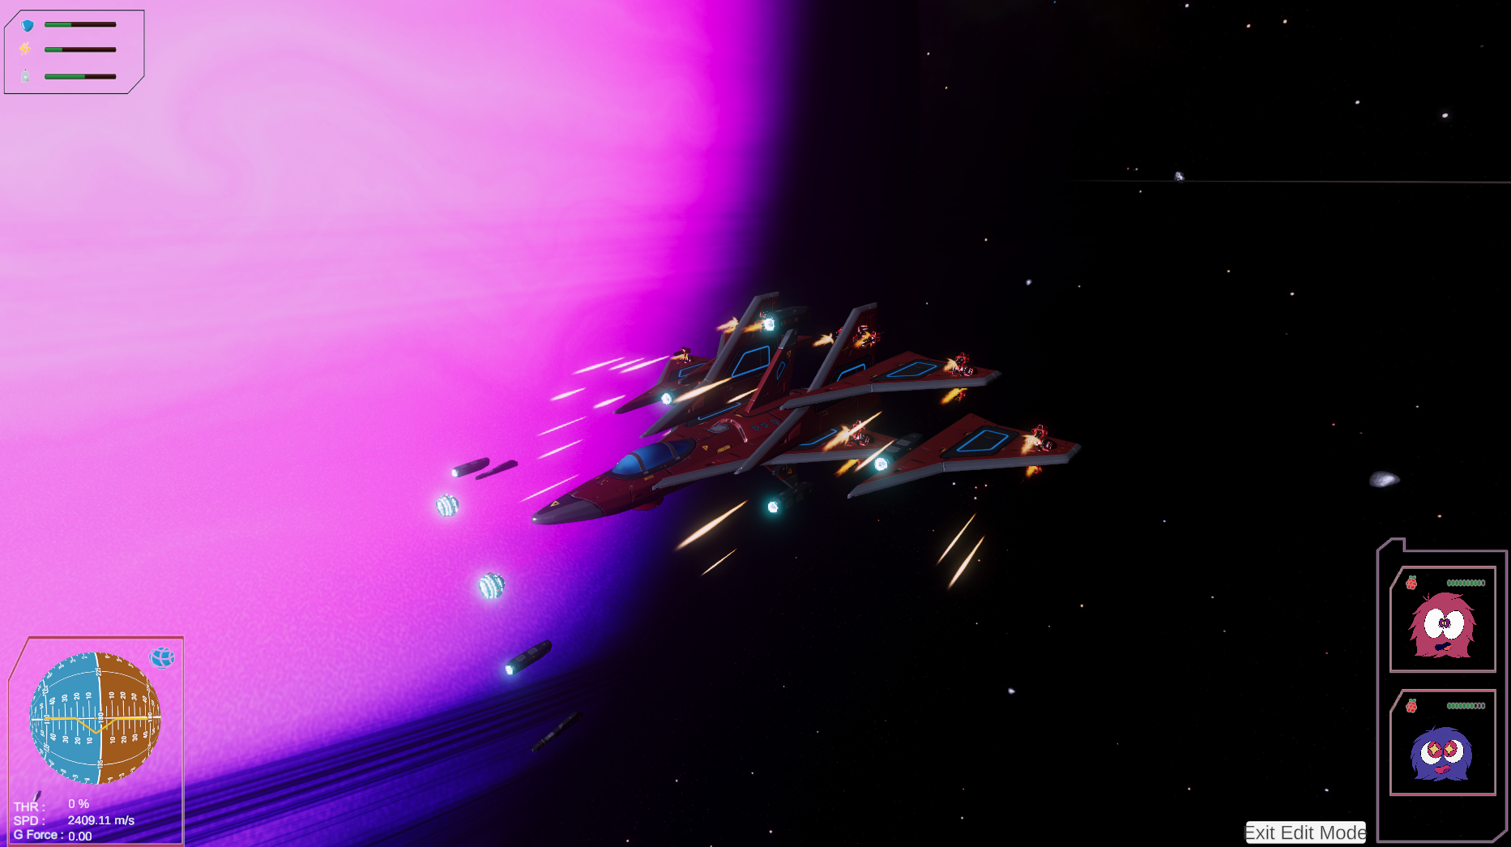
Realistic behavior of Spaceship

In our game we decided to add the feature of removable and attachable ship parts, each with its own unique shape, weight and set of Reaction control (RCS) thrusters. In order to achieve that and still have the playership behaving in a realistic manner, e.g asymmetric thrust , unity’s rigidbody system built for singular objects does not have the capability to do that. The main issue is that multiple objects parented together does not have a combined inertia, whereas they are treated as a singular object with the weight of all the objects but shaped like the parent object, resulting in unrealistic behaviors.

In order to achieve realistic ship behaviors,no matter what the player attached together. We recreated unity’s rigidbody system externally while rescuing some of the default rigidbody features to get properties of each object/modules, and combined together to obtain a composite tensor, which allows us to mathematically represent how a object like a ship react to external forces like those from a thrusting engine or a reaction control system.

Control Of Spaceship

Control of a spacecraft in space is a non-trivial task. In space, unlike aircraft, players have to control the spacecraft in all 6 axes, these are translational x,y,z and rotational x,y,z axis. Translation governs how the spacecraft moves in 3 axis space, like forward, up , left and so on while rotational axis governs the pitch roll and yaw of the spacecraft much like an aircraft. Unity has no built in control, these movements are controlled by the firing of tens or even hundreds of thrusters located around the ship. It is impossible for a player to control how a ship moves by micromanaging how each thrusters fires.

We have created a hybrid solution that draws inspiration from various space games and real spacecrafts. Perhaps this is the only space game that uses this control scheme. At its core the player controls the spacecraft pitch and yaw via the mouse. The player simply points to where they want the ship to point, and an proportional integral and derivative system (PID) fires the required thrusters to achieve that orientation. Translational movement can be hence controlled by the keyboard, similar to character movement in other games. The spacecraft uses a 6 closed loop PID controller to control all of the spacecraft’s 6 axes of movement.

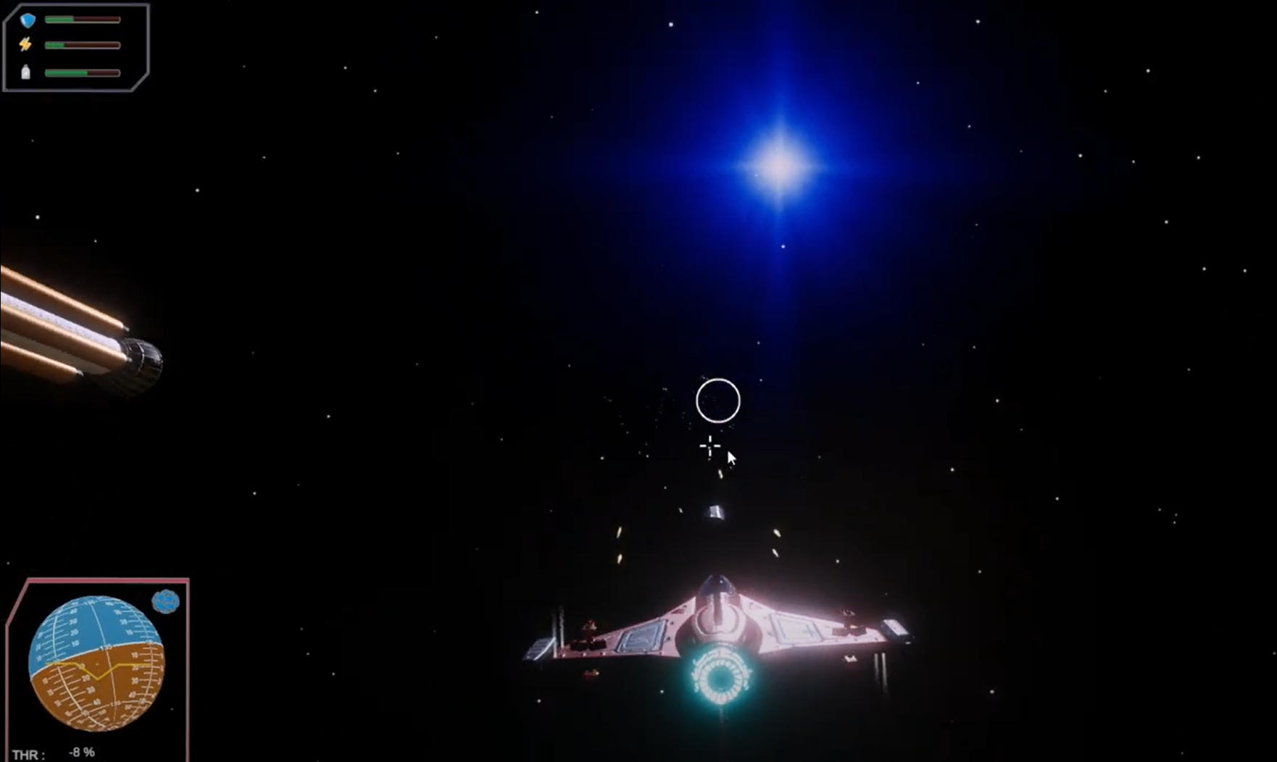

Modular Ship Construction

In our game, you can build spaceships like you're playing with building blocks in real-time. This idea was inspired by 'Captain Forever,' but we took it a step further by making it in 3D. Each part of the ship, which we call modules, was designed to easily connect with others, forming different shapes and functions. These modules can attach or detach from each other during gameplay. To build a ship you simply click to select a part, drag it over one of the orbs that show up, and then release.

Some problems that taking this idea to 3D created were figuring out where to 'float' a module when you're holding it and designing a control system that lets you manage flying your ship and building it at the same time.
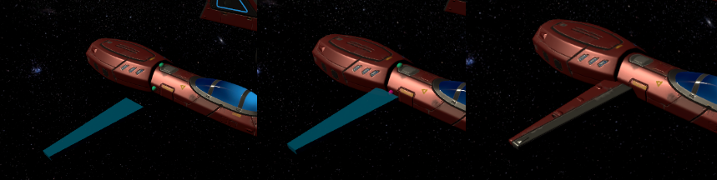

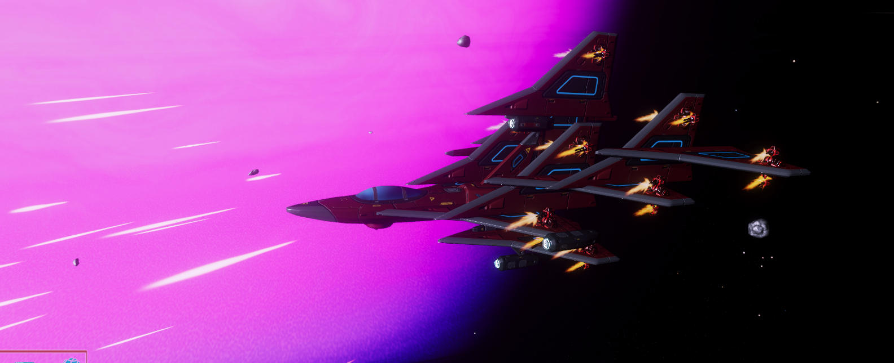

Pathfinding
Since there is no ground nor up in space - we could not use Unity’s built in pathfinding. This was not a great challenge however because space is mostly empty. All NPCs try to fly directly to their destination and use a raycast destination to see if the direct route is blocked. If it is blocked then by looking at the bounds of the obstacle an intermediate point to get around it can be found.

Object Avoidance
Compared to the pathfinding the NPC have a rather robust object avoidance system broken into three steps
- An NPC looks at a short radius around it with an overlap sphere to see if anything is nearby and then calculates if a direction to move in that is safer if necessary.
- The NPC uses a layer that contains all ships to poll them every update and see if a collision with any is possible. If one is, it will try to avoid it.
- The NPC will fire a spherecast in the direction it is moving every update to check for obstacles it might fly into so it can try to avoid them.

Applying Movement
In order to combine the instruction with all these various movement steps - instead of each step making the ship move in of itself, they simply return the way it should move for that task. Then in the physics step all of the results from each step are summed and normalized and then sent to the PID controller to get translated into actual movement. This makes sure that the various steps don't compete with each other and that the most important move will get priority. The most important move gets priority because the steps produce bigger acceleration requests the more urgent their task is. When the normalization step happens only the most important move survives.

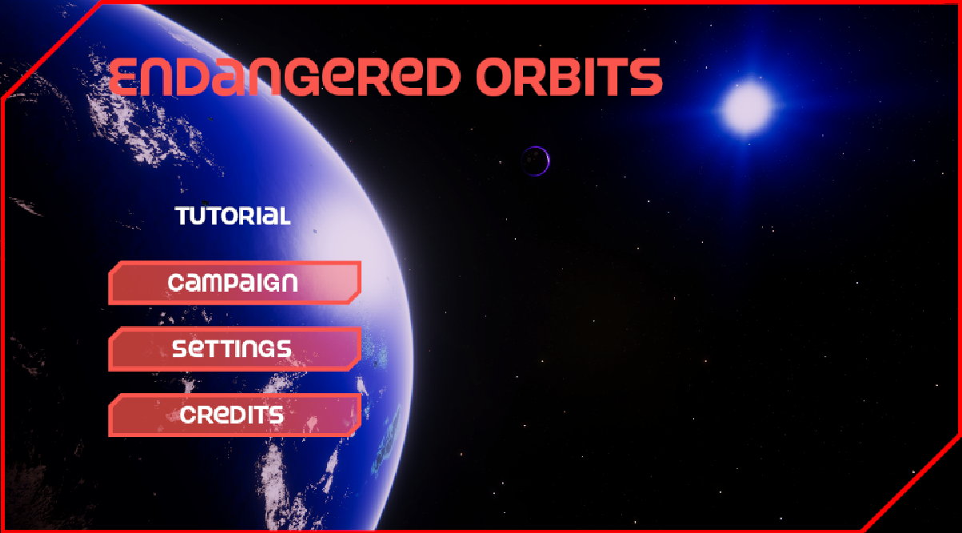

The Start Menu, which has options like Campaign, Settings,and Credits is part of the User Interface (UI). The finalized Start Menu is made to be both aesthetically pleasing and easy to use. The UI also includes the Credits Screen, Paused Screen, and Loading Screen—all of which are controlled by different scripts. While the LoadingScreen script mimics the loading process, the PauseMenu script manages the user interface when the screen is paused. With a "Back" button to take users back to the main menu, the CreditsScreen script controls the credits screen user interface.

*Section below contains LOTS OF MATH - skip if you don’t want a headache.

Math and Physics By Jacob Tang
In this section I will discuss the various math and physics implemented in the game. The game is designed across two main modules, the planetarium module and the ship module. The planetarium module contains all orbital mechanics as well as all celestial bodies, the ship module contains all ship related items. Both modules are designed to interface with each other however they are rendered in different layers to simulate different scenes using unity’s layering system. Combining both modules produced the final game.

Math and Physics - Planetarium Module

The planetarium module is responsible for containing all code and objects relating to orbital mechanics, as well as graphical elements like planets, atmospheres and stars.

Component | Key Function | Source (Exclude dependencies)
Keplerian | - Reference frames  - Converts a set of keplerian elements to state vectors to initialize positions of objects  - Converts a set of state vectors back to keplerian parameters  - Keep track of time.  - Floating origin | - Planetarium.cs  - PlanetariumSingleton.cs  - DrawOrbitLines.cs  - Orbit.cs
Orbital Integrator | - Classical 2 body orbit solver  - N-body orbit integrator | - Orbit.cs
Atmosphere | - Real time atmospheric scattering for planets | - Atmosphere.cs  - Atmosphere.Shader  - Atmosphere.hlsl

Keplerian Component - Time

The core function is firstly to keep track of time. An initial time is set and time is integrated in a fixed update. This takes into account time warp. Time will be used to calculate the position of celestial planets whose orbits are determined with respect to time.

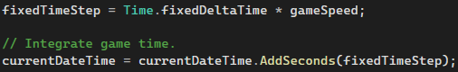

Keplerian Component - Reference Frame

Reference frame is important for all keplerian orbits.

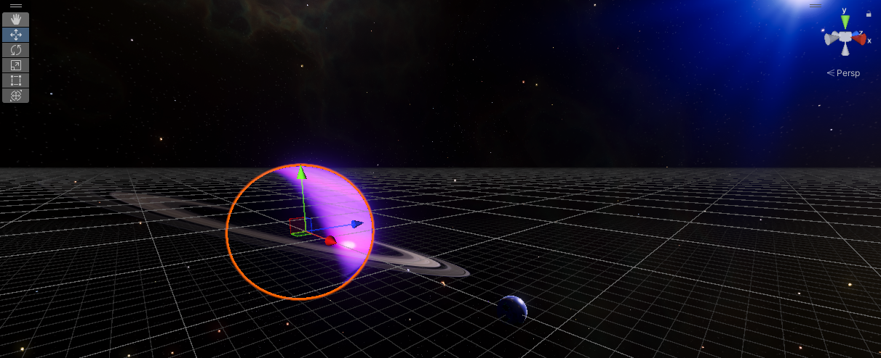

Given the example above heliocentric inertial frame , let's consider the blue giant orbiting the star, notice that the white gridlines are parallel to the horizontal axis of gamespace, this shall represent the parent body’s ecliptic plane, this is the plane at which the orbit of the blue giant resides. Other planes can be defined, the vernal and equinox is equivalent to the red arrow , this is also where the blue giant’s equatorial plane (same as its rings) intersects the ecliptic plane of its parent. The blue arrow represents the vector that points to the parent or solstices. Definitions of the ecliptic planes are located in Orbit.cs and are constantly updated based on the local forward transform of the parent body or equatorial plane.

(Left is the initialization of direction and right is direction updating based on the parent equatorial frame.)
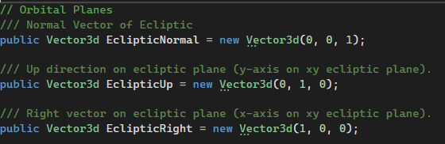
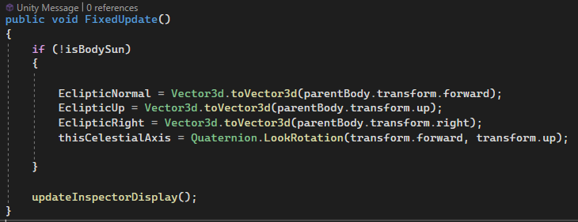

State vector reference frames

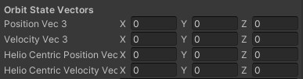
For each celestial object or satellite object, there are 2 main reference frames, the parent reference frame, and heliocentric reference frame. Parent reference frame stores position and velocity relative to the object's orbiting body. E.g the moon’s parent is earth. Heliocentric reference frame stores position and velocity relative to the geometric center of the sun or heliocentric body (this can also be the blue giant). In Orbit.cs, position and velocity refers to the “parent centric“ frame and helio represents the heliocentric frame.

Keplerian Component - Orbit Elements to state vector (Position and velocity)

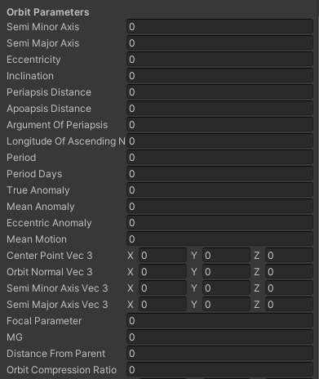
Orbit.cs defines all keplerian elements as shown on the left. These parameters are calculated in real time.

- Eccentricity - the shape of the orbit ellipse, an eccentricity of 0 represents a perfectly circular orbit while an eccentricity of 1 or more represents a hyperbolic orbit or escape orbit. For reference our moon’s orbit is quite circular around earth and is around e = 0.055
- Semi Major Axis - The max “height” of the orbiting body relative to the geometric center of the parent body. (In reality the parent body wobbles so it's more of the “Averaged center”)
- Semi Minor Axis - The smallest “Height” of the orbiting body relative to the geometric center of the parent body
- Apoapsis - semi major axis minus planetary radius. Often used to measure altitude adobe ground level (AGL)
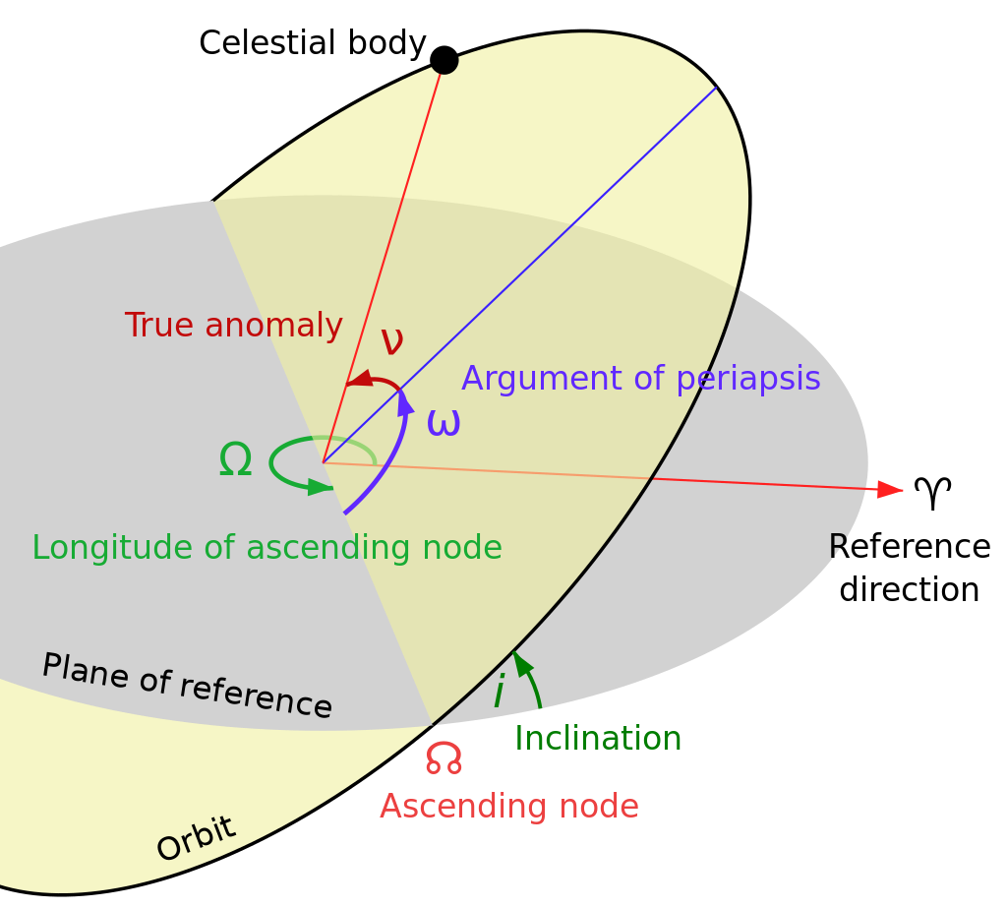
- Periapsis - semi minor axis minus planetary radius , or closest distance an object will be relative to the parent’s AGL
- Semi Major Axis Vector - semi major axis in vector form.
- Semi minor Axis Vector - semi minor axis in vector form.
- Inclination - the angle of the orbiting body’s orbital plane relative to the parent’s equatorial plane. Where 0 means the object orbits perfectly around the parent’s equator, 90 where the orbit passes perfectly around the parent’s poles.
- Longitude of ascending Node (LAN) - In reality a place can be tilted as described by inclination but it can also yaw around the polar axis of the parent, this yaw angle is the LAN. The reference direction is represented by the parent’s ecliptic right (red arrow).
- Ascending Node - vector of each orbit pointing in the direction where it intersects with the parent’s equatorial plane.
- Argument of Periapsis (AOP) - Suppose the eccentricity is ~0.2, which means an egg shape like orbit. The highest and lowest point of the orbit can only be in one direction, or angle. That direction at which the periapsis is located relative to the ascending node is AOP.
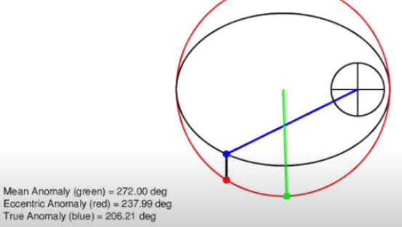
- True Anomaly - The angle E of the elliptical orbit. X being the reference direction as mentioned above.
- Mean Anomaly - Similar to true anomaly but the elliptical orbit is “squished” into a circular orbit.

Keplerian Component - State vector from Orbit Parameters

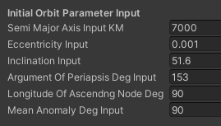
For each celestial object as well as satellite objects, we need to define an initial starting condition for it. While we can just put them in the scene, by defining the orbit parameters, we can be confident that the initialized state vectors will be accurate. These inputs are shown on the left for each object in Orbit.cs.

Below in sequence is the mathematical determination of state vectors from the above input.

Step 1 : Determine the standard gravitational parameter (μ) of the parent body.
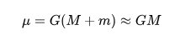
Where:
G is the gravitational constant (.0667430e-11)
M is the mass in KG of the parent body.

Step 2 : Calculate Semi Minor axis from Semi Major axis
.
If e < 1
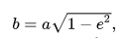
Where:
a is the semi major axis input.
e is the eccentricity input.

If e > 1
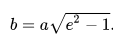
Where:
a is the semi major axis input.
e is the eccentricity input.Where:

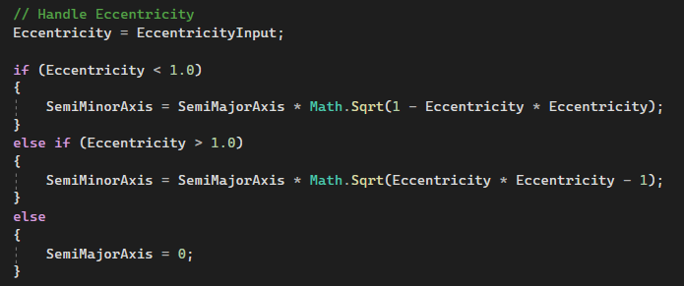

Step 3 : Get ascending node and orbit normal directions
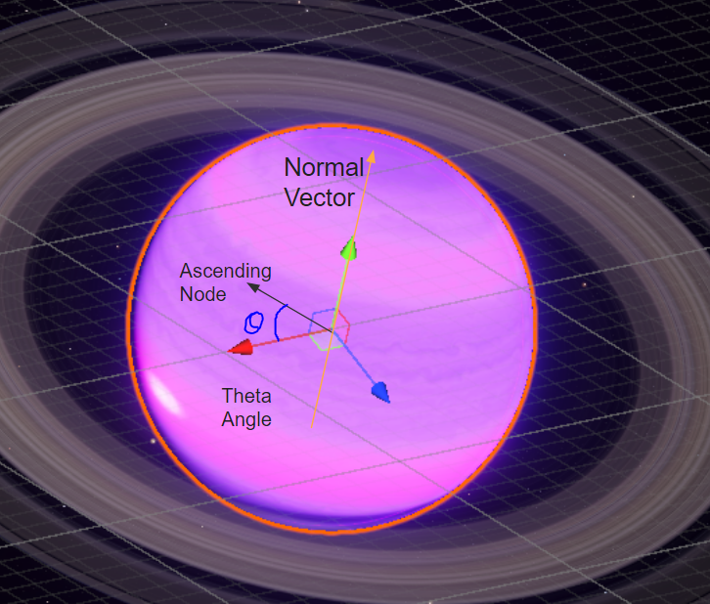
This is done by calculating the vector of the parent's local red arrow or the ecliptic right. Given the longitude of the ascending node input and the normal vector of the parent, we rotate the red arrow by angle (LAN) around the normal vector to obtain an ascending node.

This is done by a custom modified function that applies a rotation angle , v is the vector to rotate e.g ecliptic right, and rotate around is vector n or the normal vector.

In the rotation matrix below, vector R is the result rotation matrix, u is the axis, and theta is the angle.

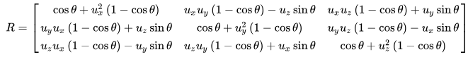

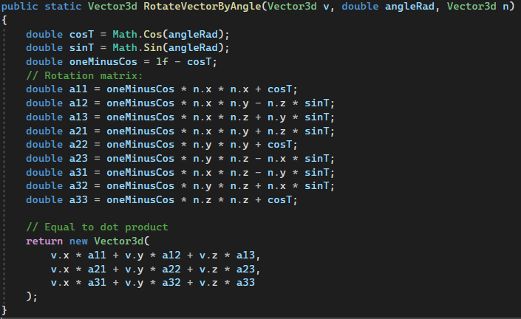

To obtain the result vector, we take the rotation R DOT product by the input vector. The same concept applied to inclination to obtain orbit normal using inclination input.

Note : Orbit normal dot ecliptic normal used to determine the direction of orbit.

.Step 4 : Determine orbit period

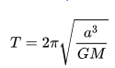
Where:
a is the semi minor axis as determined before.
T orbit period in seconds.

Step 5 : Determine Semi major / minor basis vectors.

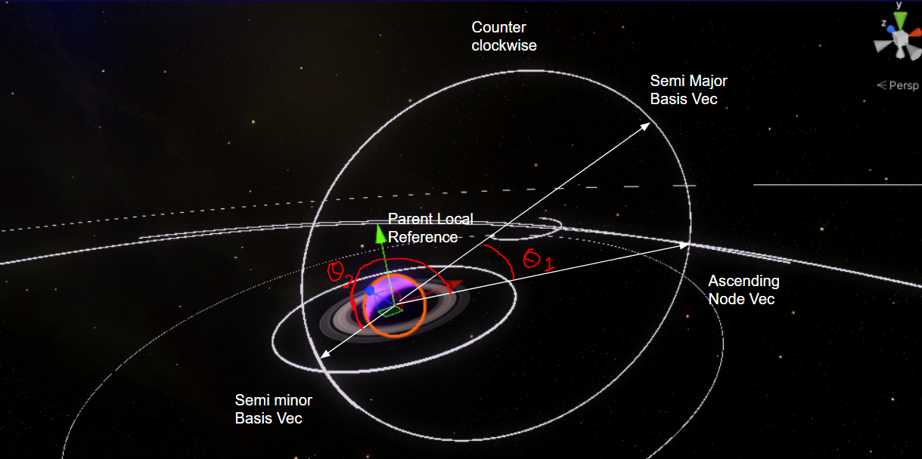

Using the above convention, we can determine both vectors by rotating the ascending node vector by the argument of periapsis angle AOP input angle into theta 2 , then semi major axis basis is simply the opposite direction (Or cross product of periapsis and parent normal axis)

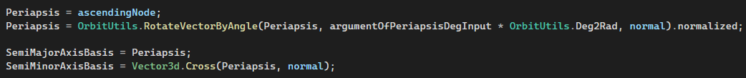

Note that the semi major basis and minor basis is a direction vector only .

We can obtain vector form of semi major and minor axis by:

Semi major Axis vector = Semi major Axis Basis (direction) * semi major axis (scalar km)
Semi minor Axis vector = Semi minor Axis Basis (direction) * semi minor axis (scalar km)

Apoapsis (Scalar km) = Semi major Axis vector.magnitude - parent body radius;
periapsis (Scalar km) = Semi minor Axis vector.magnitude - parent body radius;

* Conditions based on eccentricity
- If the eccentricity is < 1, then the semi major axis axis and apoapsis.
- If the eccentricity is => 1, then the semi major axis axis and apoapsis do not exist.

Step 6 : Calculate eccentric anomalies from mean anomaly input.

*If the eccentricity is < 1, a elliptical orbit, we use mean anomaly

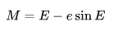
Where:
V is the input true anomaly (radians)
e is eccentric.
E is an eccentric anomaly.

Since the user inputs a true anomaly, we have to convert it to an eccentric anomaly. However looking at the formula we can see that there’s no straightforward way to solve this since there are 2 values of E.

In order to solve this we have to use Newton-Raphson iterative method. Given a Epsilon or uncertainty, we can iterate on the formula below to get results that are within the epsilon to the actual value.

In practice we can calculate n or iterations based on eccentricity. Based on some sources, a reasonable iteration n would be 2 for orbits that are circular and 6 for orbits that are close to hyperbolic.

https://scicomp.stackexchange.com/questions/40700/solving-keplers-equation-with-newton-raphson-method
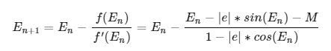
Where:
En is the eccentric anatomy for each iteration
M is the mean anomaly.

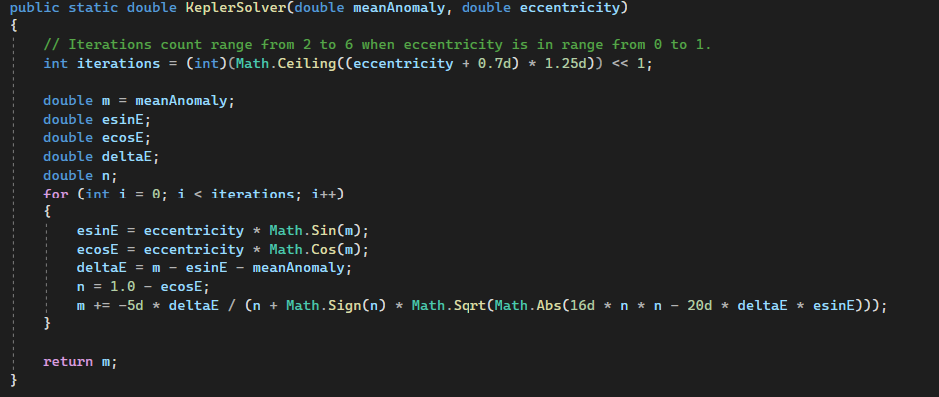

*If the eccentricity is < 1, a hyperbolic orbit, we use hyperbolic anomaly, where the hyperbolic anomaly is defined as area F as shown below :

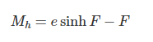
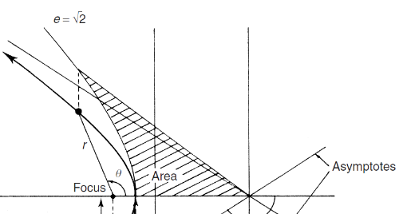
For hyperbolic case,

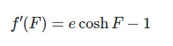

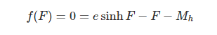

Where:
F is the hyperbolic anomaly area.
Mh is the mean anatomy at iteration h
Delta is the epsilon value. Or accuracy. Typically epsilon 1e-8.

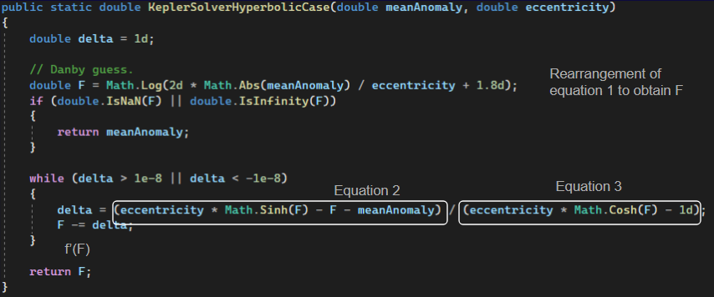

Step 7 : Obtain position from eccentric anomaly.

By applying pythagoras theorem, we can obtain position using eccentric anomaly and semi major axis.
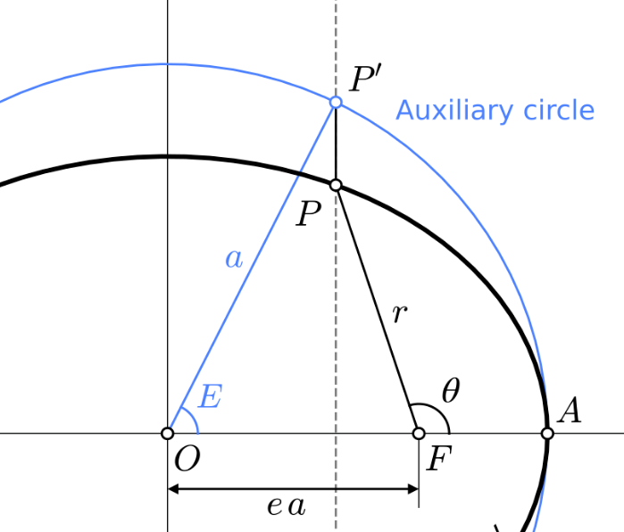
We can calculate the length of ea since we know that the distance from F to A is simply the semi minor axis and the distance from O to A is simply half of the sum of the semi major axis and semi minor axis.

Where:
O is the center focus.
F is the origin of the parent body.
a is semi major axis
|OA| and |ea| are the lengths
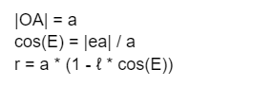
ℓ is eccentricity
E is eccentric vector
P’ is the eccentric position
P is the position
R is the radius vector
To obtain the position relative to parent, imagine where F = 0, then the vector position P’ will simply be the semi major axis basis (vector pointing from F to P) multiplied by scalar r.

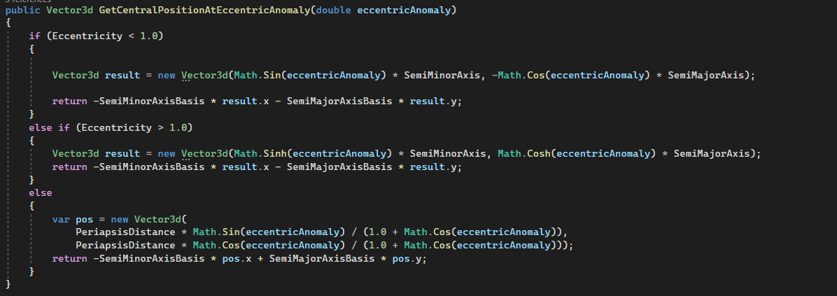

If the orbit is an ellipse, then we can use the normal trig function. If it is a hyperbolic orbit, then we need to use the hyperbolic trig function.

Step 8 : Obtain velocity from true anomaly.

Velocity calculation uses true anomaly. We need to Convert eccentric anomaly to true. This can be done using the formula:

If the orbit is ellipse:
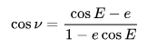
Where :
E is the eccentric anomaly.
e is the eccentricity

*If the orbit is hyperbolic simply use hyperbolic trig functions.
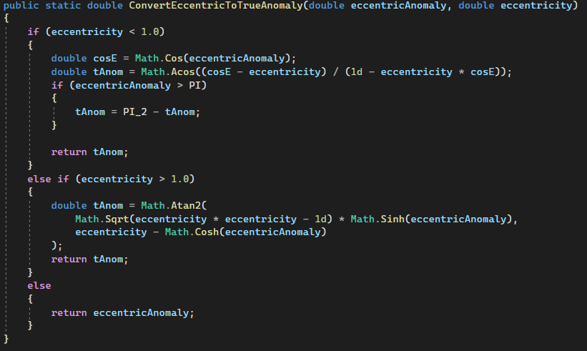

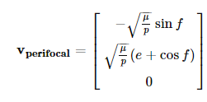
Velocity can be obtained easily from the following formula below (Code is outdated not shown):

Perifocal reference frame (PQW):

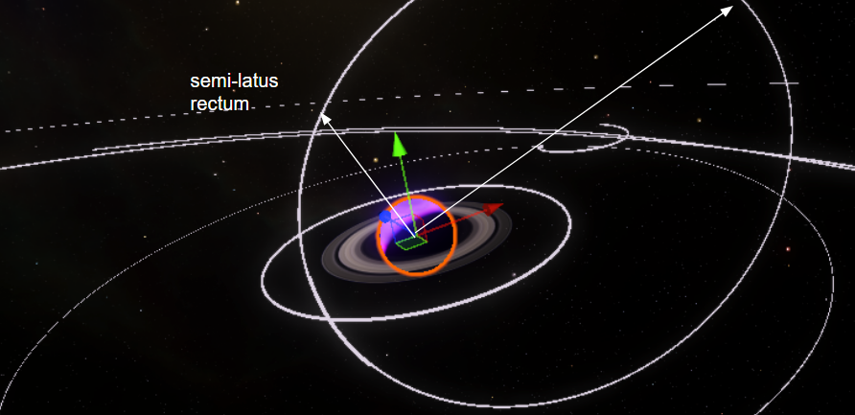

Where:
V is the velocity vector
f is the true anomaly
p is the semi-latus rectum
Μ is standard gravitational parameter of parent (GM)
e is the eccentricity

State vector to Orbital Elements

The same operation has to be performed in reverse where an object's state vector, its position and velocity are converted to orbital parameters. This is primarily used by N-body simulations, whereupon each integration step, the resultant position and velocity converted back to orbital parameters for display or trajectory planning. The steps used to obtain the keplerian parameters are displayed below. For now we only investigate the

Step 1: Obtaining Eccentric Vector
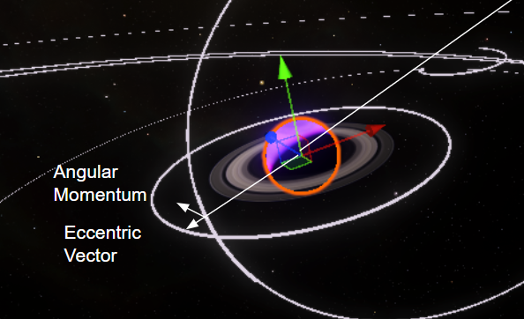
The eccentric vector as shown below is a vector that points from the parent body’s center to the periapsis of the orbit. This vector would allow us to determine various orbital parameters like the argument of periapsis angle as well as direction to apoapsis if the direction is inverted. The reason to find an eccentric vector first as this vector is a function of the position vector and velocity vector, by finding the angular momentum vector.

Consider the equation below for eccentric vector e:
*Note that position and velocity are relative to the parent orbiting body only.

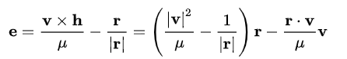

Where:
e is the eccentric vector pointing to periapsis
|e| the magnitude of e is eccentricity
R is the position vector
V is the velocity vector
h is the specific angular momentum vector (where h = the cross product of position and velocity)
Mu is the equal to GM of parent (standard gravitational parameter)
Step 2: Obtaining Semi major and minor
*Focal parameters are no longer needed in this section.

We need to firstly obtain the focus position of the orbit as shown below. Determination of the focal Parameter (distance from the directrix to the focus point).
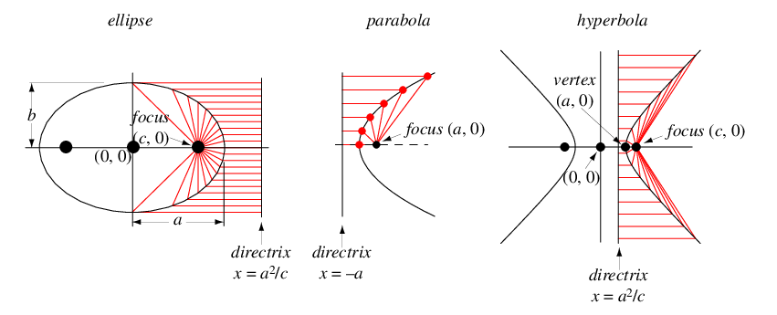
p = |h|² / μ
Where:
P is the focal parameter
h is the magnitude of angular momentum squared
Mu is the parent's gravitational parameter.

*Focal parameters are no longer needed in this section.

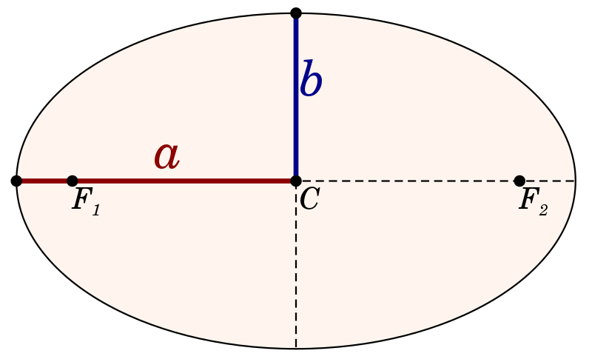
The semi-minor axis basis or the direction to vector b can be determined by taking the cross product of the eccentric vector (same direction from c to f1, going left) and the angular momentum vector (which points downwards in the picture on the right). Since the angular momentum vector points down given the orbit is clockwise, the resultant b will be pointing downwards. To get the upwards b vector, we have to inverse either angular momentum vector or eccentric eccentric vector. The semi major basis or the direction of vector a can be determined by rotating vector b by 90 degrees with the axis pointing upwards, this axis would be the orbit normal.

The semi major and minor vector can be hence determined by taking the semi major and minor basis multiplied by the scalar distance. To get the semi minor axis, we need to find the size of the ellipse, or distance from apoapsis and periapsis divided by half, and multiplied by the direction vector semi major basis. To find b, we need to know the shape of the ellipse, the compression ratio, where a compression ratio of 1 means a perfectly circular orbit, the more elliptical the orbit the lower the compression ratio. (semi minor distance / semi major distance * 2).
Derivation of distance for a and b can be done below:
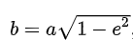
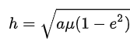

Where:
h is the angular momentum vector
a is the semi major axis distance
b is the semi minor axis distance
e is the eccentricity (eccentric vector magnitude)
Mu is the gravitational parameter GM of the parent.

*Section to be updated in code.

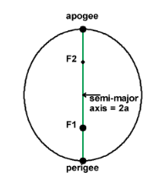
To determine the apogee, we can use the semi major axis where the distance between apogee and perigee is 2 times of the semi major axis.

Where :
Center Point position vector (Relative to parent origin) = semi major axis basis * semi major axis * eccentricity

Apogee vector = centerpoint vector - (semi major basis direction vector * a)

Perigee vector = centerpoint vector + (semi major basis direction vector * a)

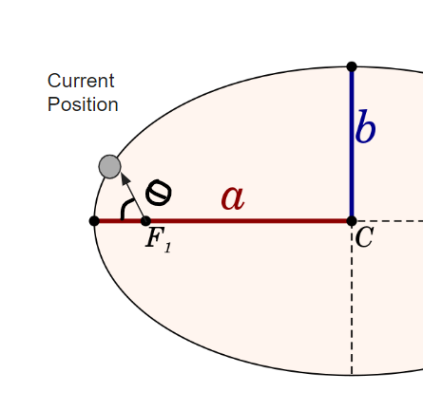
Apogee and perigee distance can then be calculated from the magnitude of apogee vector or perigee vector minus the planetary parent radius.

Step 3: True anomaly
True anomaly can be calculated easily by taking the angle between the current position vector from the focal point or (0,0,0) in the inertial frame and the semi-major axis basis direction vector.

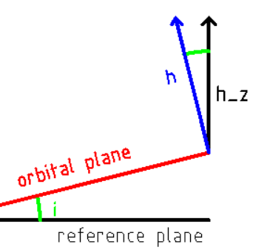
Step 4: Inclination
Obtaining inclination is done using the principal from the diagram on the right. Suppose vector h and h_z are known , and the relationship between theta, h and h_z is the dot product, we can hence express inclination in the following format:

Inclination (Theta) = Acos(h dot h_z)

Where:
h is the normal of the orbital plane
H_z is the up axis of the parent’s equatorial plane
Theta is the inclination in radians
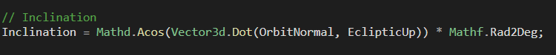

Step 5: Longitude of ascending node
First we have to obtain the ascending node vector. This vector is the intersection of the object's orbital plane and the parent's equatorial plane. The direction of the ascending node depends on the clockwise or counter clockwise rotation of the orbit (prograde or retrograde).

First we have to obtain the vector n, pointing from the parent's origin. This can be calculated from the -y and x component of the specific angular momentum vector as shown below or the cross product between the orbital plane and parent’s equatorial plane plane.
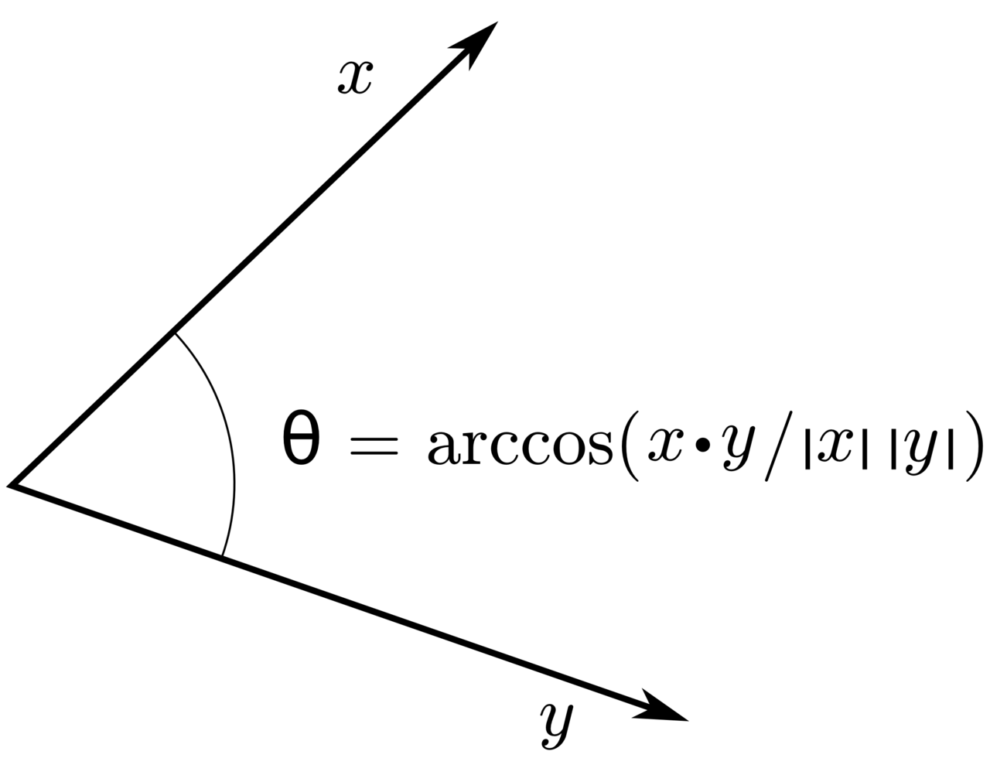
To determine the angle, since we have the ascending node direction vector, and the reference direction of the parent, basically the right transform of the parent body game object, we can determine the angle difference between them using the dot product as shown on the right.

Recall that the dot product angle is always <180 degrees, for LANs of above 180 degrees we need to find out which side it is on. By taking the cross product of the ascending node and the reference direction, we have a 3rd vector that is perpendicular to those two vectors in the up if the ascending node direction is left, and vice versa.

Taking the dot product of the 3rd vector against the equatorial plane up direction, we get an angle positive or negative. If the ascending node is greater than 180, suppose it is 190 then the result angle will be 10 and the dot product will be positive hence choosing which if statement to run.

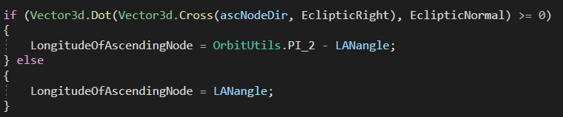

N-Body integrator

In the orbit.cs , the implemented option allows the user to select a simple keplerian orbit or complex N-body integrator. Especially for the player ship, we would want an N-body integrator to be the orbit propagator of choice. In order to support multi timescales, like time warps while maintaining accuracy, we implemented Newton's equations along with a Runge Kutta 4th and 8th order scheme.

The core operation is Newton's law of universal gravitation which states that the force acting on one object is proportional to the Mu or the parent’s gravitational constant and its distance squared (Left). The vector form of this formula can be written to calculate the force vector given positions of the parent object (Right). To account for all bodies, the vector form equation can be modified to account for forces of attraction as a result of N number of celestial bodies. Note that for M2, since spacecraft mass is insignificant compared to the planet, it is assumed to be zero.
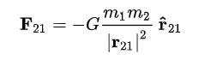
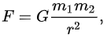

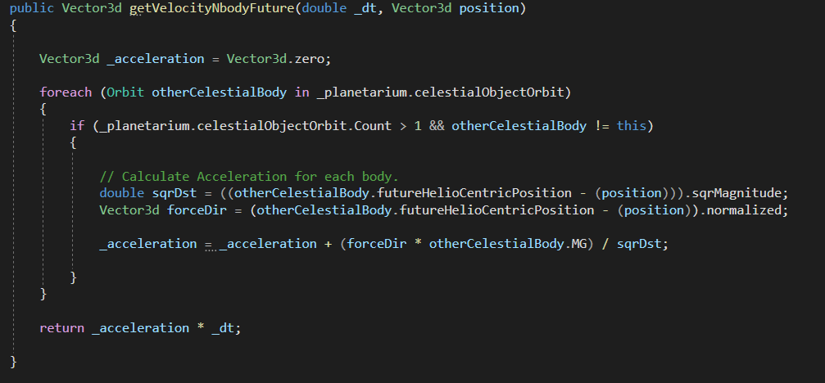
A discrete time step is used to calculate the resultant acceleration from the force over that discrete time. However, like all euler methods, we have to use very small time steps to achieve an acceptable level of accuracy , <0.01 seconds.

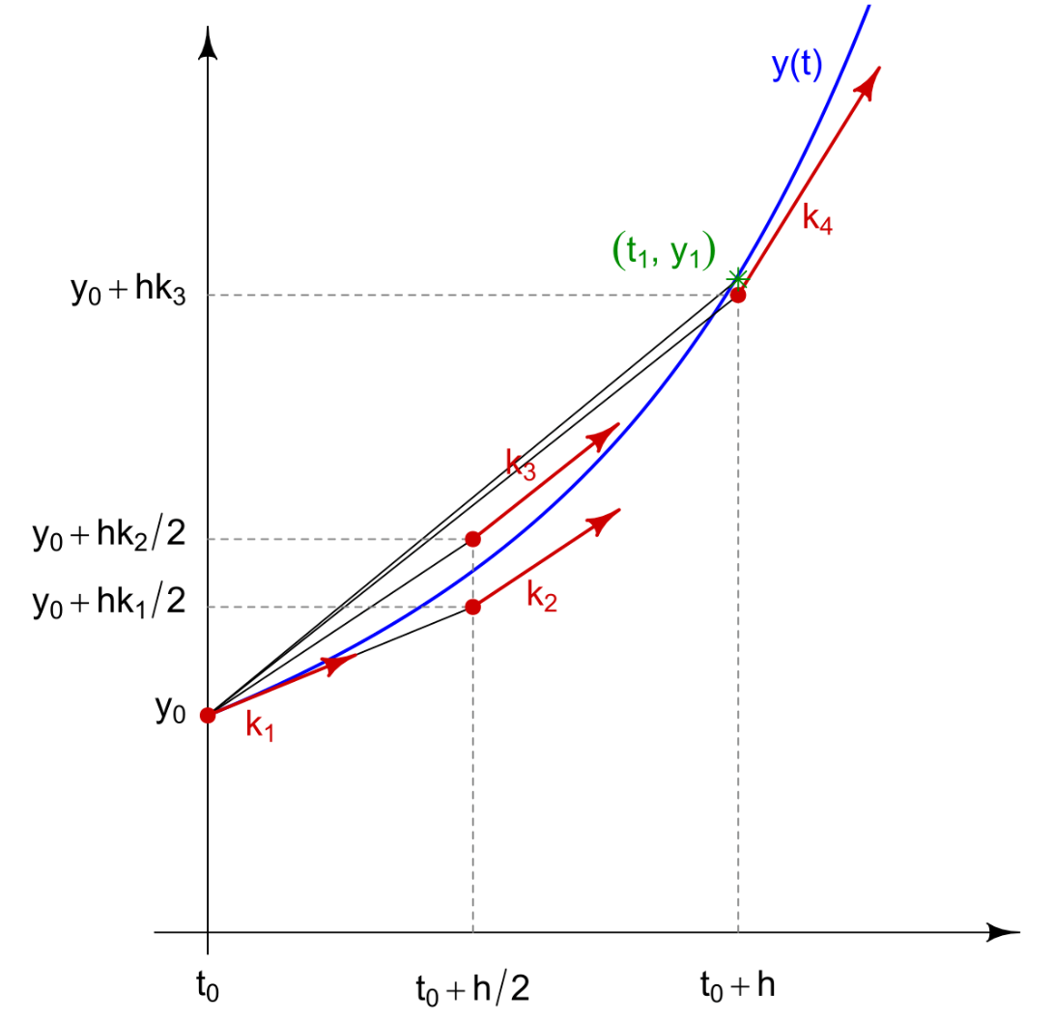
Numerical Runge Kutta Methods
Numerical methods like Runge Kutta allow us to use much larger discrete time steps to perform the calculations as shown above. When we are using the Euler method , if the timestep becomes too large, there will be large uncertainties in each iteration, or error. This error will be integrated and over many timesteps, builds up. This results in orbits not behaving as expected, like magically gaining or losing energy.

In the RK 4th order scheme as shown on the right, we are using 4 discrete substeps within the timesteps to calculate the instantaneous gradient of the function, then by using the scheme we can combine the result of k1 ,k2, k3, k4 into a combined result, which provides accuracy that approximates euler methods with very small discrete time steps.

RK 4 Scheme
For most low time warp options, a RK4 scheme should provide reasonable accuracy. Currently the planetarium module utilizes RK4 for all integration time steps, perhaps in the future this would be dynamic based on an energy conservation epsilon like 1e-8. Nevertheless the first part of the scheme is to find the K coefficients, k1, k2, k3, k4. These are expressed below:

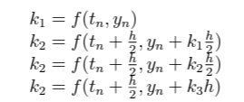
Where:
Tn -> not used
h is the timestep or
delta time.

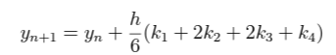
When combined using the equation here, the result is obtained.

Some modifications are required to make this scheme work in order to integrate both position and velocity, for each k coefficient, there is the kn_v component and the kn_x component, where v is the velocity, x is the position. *Replaced r with x
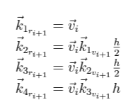
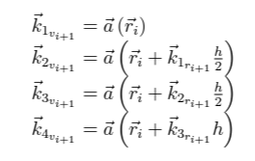

The left equation sets are the velocity component, or v in the code, the right side equation sets are the position component. The result of both v and x can be calculated using the equation sets below:
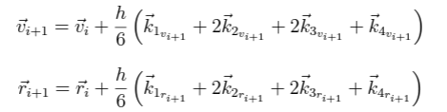

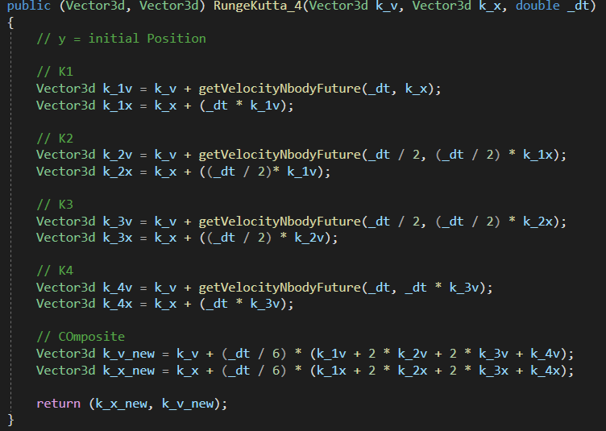

RK 8 Scheme
For higher timesteps, we need a scheme of higher order to maintain accuracy. This would be used for instance to draw orbit line predictions for interplanetary travel. The RK8 scheme in principle is similar to RK4 as described, however it consists of a set of 8 coefficients to obtain a result. RK8 scheme equation sets below showing the 8 K_n and its coefficients:

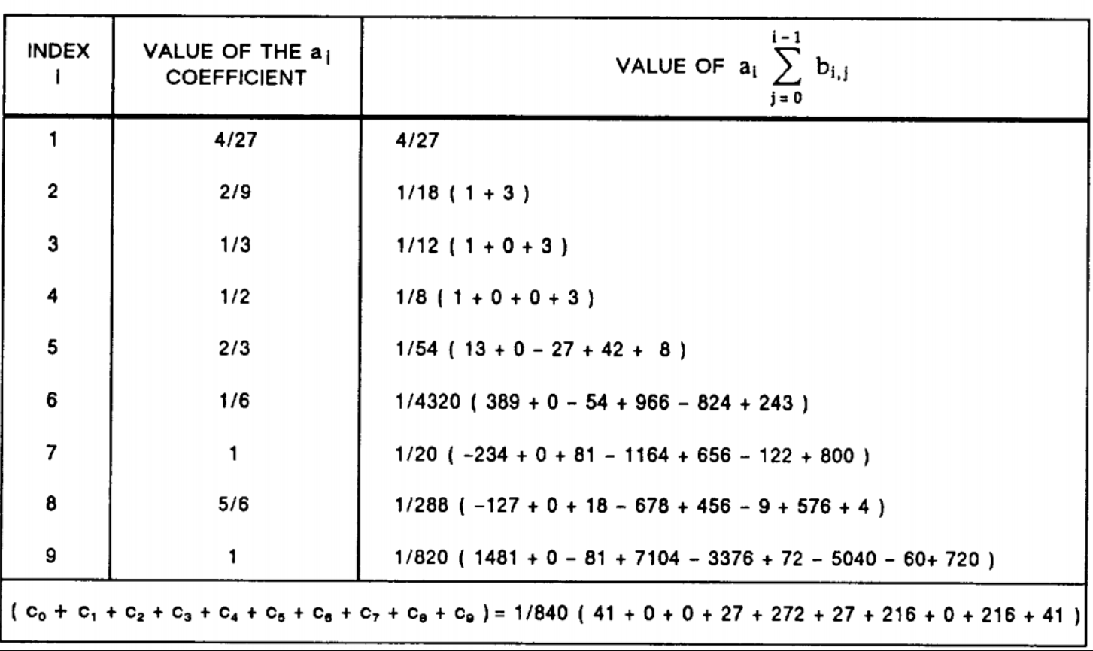

Implementation in code:

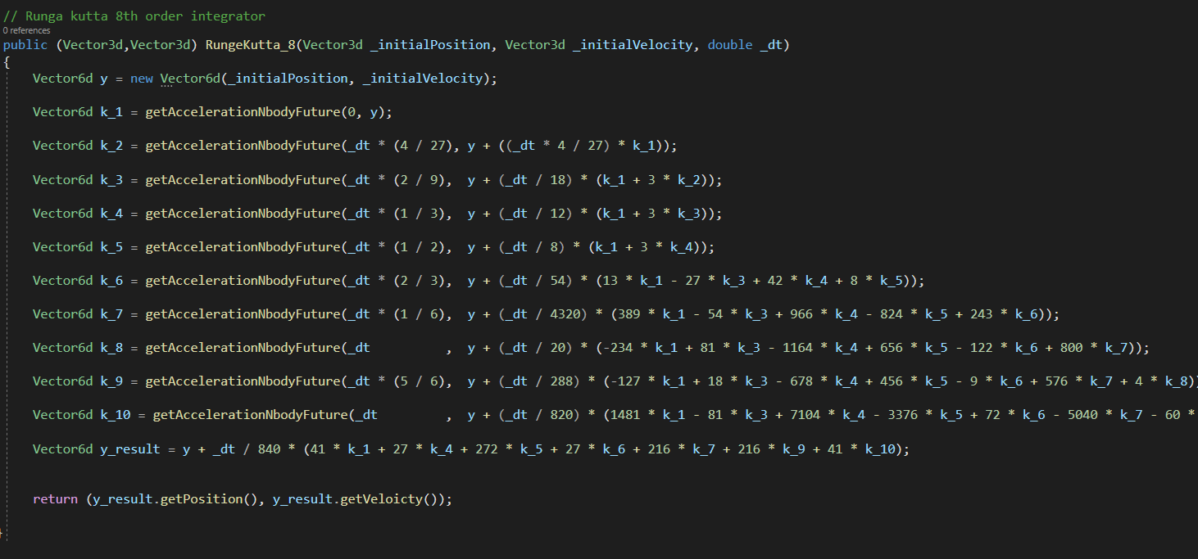

Heliocentric reference frame
In order for the integrator to take into account all objects, we must perform all numerical integrations in a reference frame that contains all celestial bodies, this reference frame should be the heliocentric frame. During the initialization phase, the calculated position and velocity of objects are in a “parent centric” frame, that is the reference frame is the equatorial frame of the parent celestial object. In order to convert parent centric frame to a heliocentric frame, we have to iterate through the tree structure, starting from the current object, traversing up the tree, to its parent and its parent to its parent and integrate all parentric positions and velocity to obtain heliocentric reference frame.

Below shows the implementation of a recursion to find parent orbits and iteration through each parent.
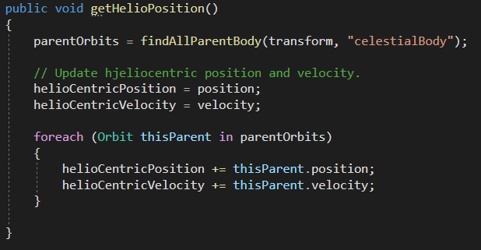

RK4 Orbit prediction
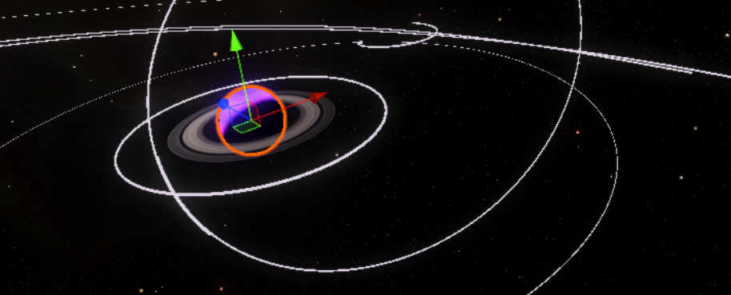
In order to predict the future orbit and thus drawing down orbit lines as shown above, we need to integrate the position of the object with respect to time separately to a defined future time, a future position and velocity. Furthermore we have to also integrate the position of all celestial bodies in the same future time. For celestial bodies, since it follows a classical Keplerian simple orbit, its position for any given future time can be calculated easily from the anomaly.

Since we have already calculated the period from the previous segments, we can calculate the mean motion, that is what will be the angular displacement of the mean anomaly given a certain elapsed time if the mean anomaly rotates a complete circle for every period .

Once mean anomaly is determined, we can calculate the position of the celestial object at given elapsed time from start of the game by first converting the mean motion to a future mean anomaly, then convert mean anomaly to eccentric anomaly using the newton-raphson method as described in the orbital elements to state vector section.

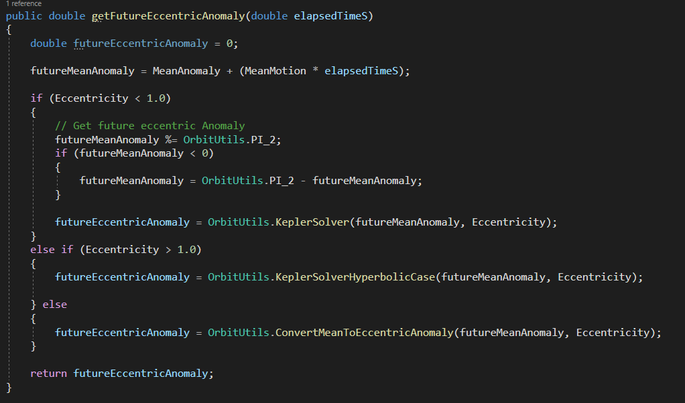

Once the future eccentric anomaly is known, we can use that to obtain the future position, which would be used as input for the orbit prediction integrator.

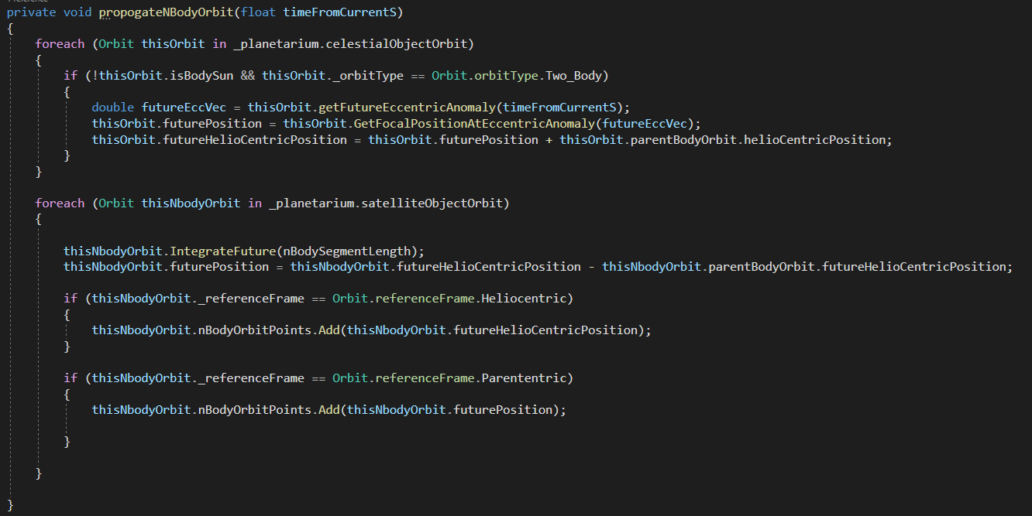

* Note the code above resides in the drawOrbitLines.cs file.

Planetarium Floating Objects
In the planetarium which contains all orbital or celestial objects, there is one and only one object that is set as the floating origin. In all cases this is the player ship. The player ship anchor is a placeholder empty object that contains all properties of the playerships orbit or state vectors. The planetarium will calculate orbital mechanics in the heliocentric frame, then for displaying, all objects are scaled down and translated to the player’s frame. The player’s frame’s origin would always be (0,0,0) in the game editor. The scaling function makes sure that objects within the game scene are of a reasonable distance apart so as to not cause rendering artifacts.

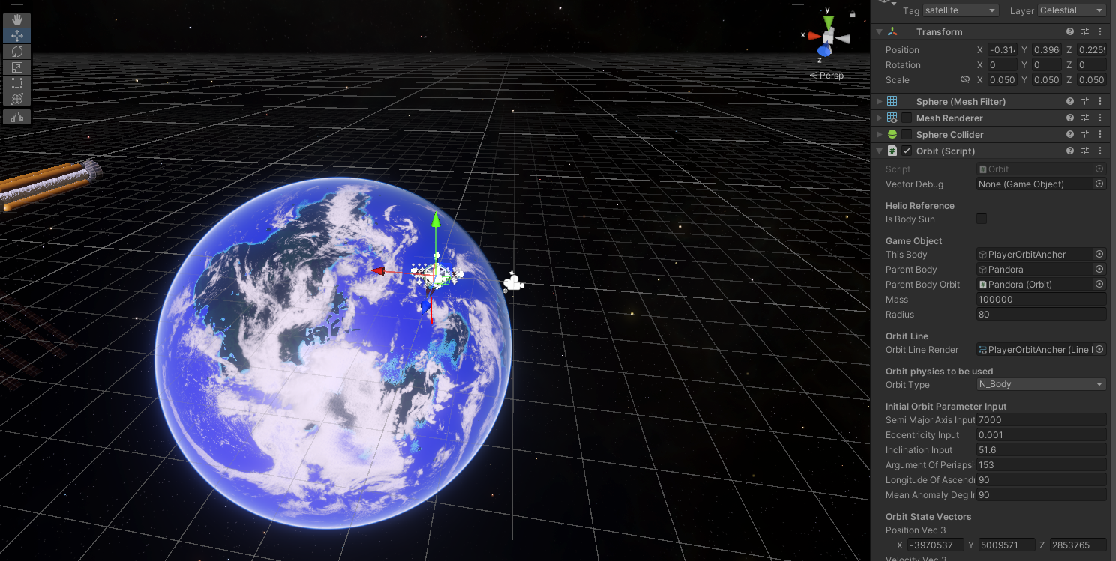

Notice in the editor screenshot above that the player ship is in the (0,0,0) position in the editor while the planet “Orbits” around the player. You can also see initial orbit parameter input in the inspector, this is where the player’s initial orbit is defined at the start of the game.

In the planetarium.cs a function runs at every update cycle for all tagged celestial or satellite objects, and the transformation vector calculated.
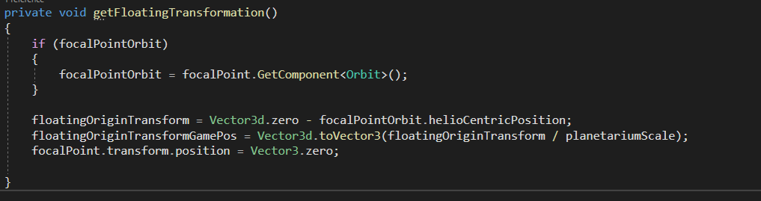

The transformation can be applied for all objects .

Atmospheric Scattering

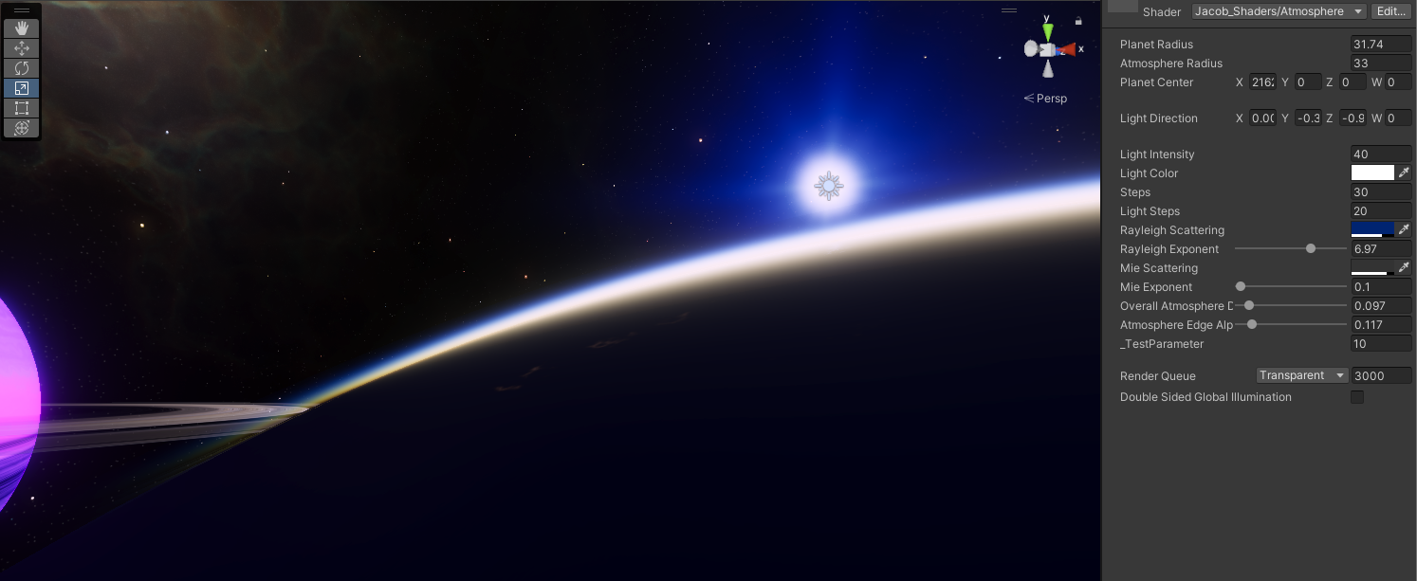

Perhaps one of the best visual components is the implementation of a physically based atmosphere scattering effect which has the ability to be instanced for each planet. Unity’s default physically based atmosphere is only available as 1 instance in a skybox and only runs in HDRP.

In order to create this effect, a mathematical model of how light scatters in the atmosphere due to gasses and particles needs to be implemented in the GPU. Additionally the scattering is a non linear problem which depends on many conditions like optical depth, light source etc… which cannot be solved easily by approximation. Hence raymarching is required to iteratively solve scattering for each pixel, which can be computationally expensive, however this greatly depends on the GPU and the number of parallel processing cores (CUDA or Stream cores).

Based on : https://developer.nvidia.com/gpugems/gpugems2/part-ii-shading-lighting-and-shadows/chapter-16-accurate-atmospheric-scattering

Mathematical model of the atmosphere
Mathematical model has to be implemented not only in the shape of the atmosphere, but also various properties of light like scattering, phase , in and out scattering functions, all implemented in the fragment shader.

The Shader

In unity like all other games, a shader is a piece of specialized code that gets compiled natively into machine code that runs exclusively on the GPU. Suppose if there's a ball in the game scene, and that it needs to be rendered, there must be a shader somewhere that tells the GPU to render the ball, where, and what color it has to render.

If we look at the example of the atmosphere shader, it is basically a bunch of code where its end result is to tell the GPU for every pixel on screen, what is the float4 value to render. This float4 is a single precision 4 column matrix where the first 3 columns are Red , green blue values, and the last element the transparency value or alpha.

The Vertex Shader

The vertex is essentially the first process in the rendering pipeline. When an object is placed in the editor, the Unity game engine stores the position of each point or vertices and its position in game space. The vertices position is passed into the vertex shader, where for each area that is enclosed by 3 adjacent vertices.
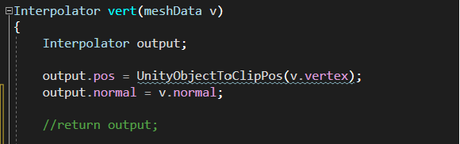
On the left the barebones vertex shader function. This function is named interpolator because its main function is to transform or interpolate the position of each vertex from game space to clip space.

Looking at the vertex function, we can see that mash data is passed in as variable v, this mesh data essentially contains position information for one vertices. Next we can see that we utilize unity’s built-in function “UnityObjectToClipPos” or the Model view projection (MVP) matrix that transforms the position v of 1 vertices from gamespace to clip space.

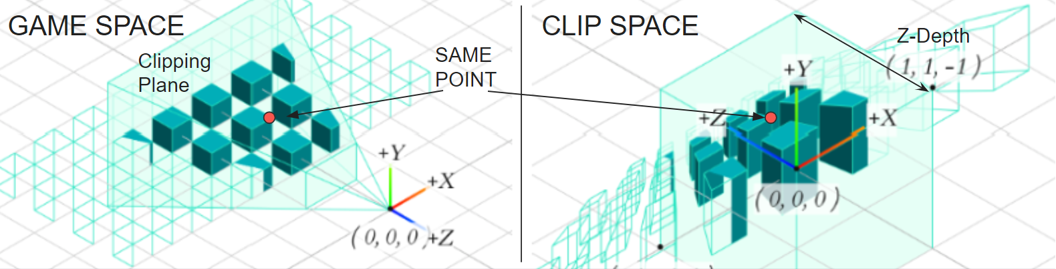

Suppose we have a vertex point p represented by the red dot in the diagram above. The point is the same point however it is clear that they exist in different positions in game space and in clip space. This change in position is the main function of the MVP matrix transformation.

Other items are calculated for instance the uv, which is the vector direction pointing to the outside facing normal direction from the vertice. This direction is important because it tells the GPU which side to render and which side not to render. View direction is the vector direction from the camera to the specific vertice.
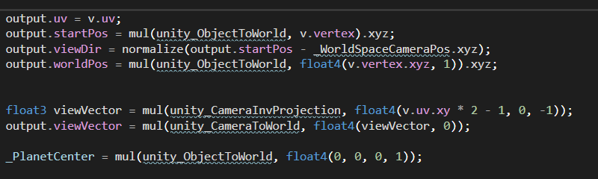

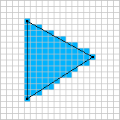
Rasterization

This function is built in and in general is automated. For every vertex shader output, 3 adjacent outputs that encircle an area are put together as a vertex. As shown on the right, 3 points which represent the output of 3 vertex shaders are combined to form the blue area. The grid pattern represents pixels on the screen and the rasterizer computes which pixels the vertex encircles.

The Fragment Shader
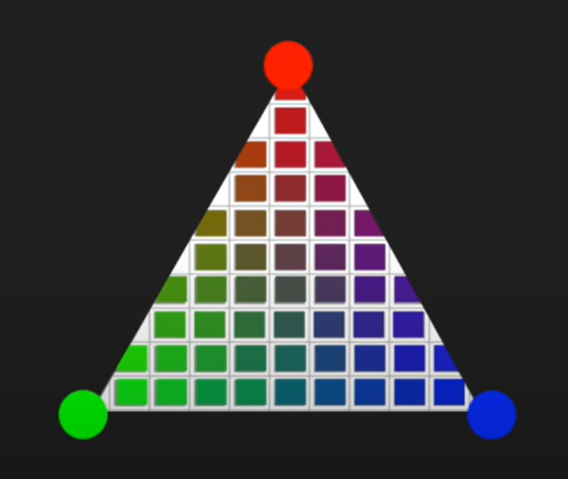
The fragment shader is a function that once again runs in the GPU for each pixel on screen. If we zoom in on the pixels as shown on the right, we can see that some pixels are only enclosed partially by the vertex (black line). Hence a pixel can be fragmented, where one side is in the vertex and another is not.

In shader code the fragment shader takes in data from the rasterized vertex. Data can be hence passed in from the vertices by the vertex shader into pixels or fragment shader. For instance if an object has 3 vertices, and the user assigned different color to each one, then the information on color of each vertices can be pass in through the vertex shader into input i in the fragment shader, then the fragment shader would average out the colors based on distance and calculates the color needed to be displayed by each pixel, resulting in a vertex to be displayed on screen with a smooth shade.

Application for atmospheric scattering

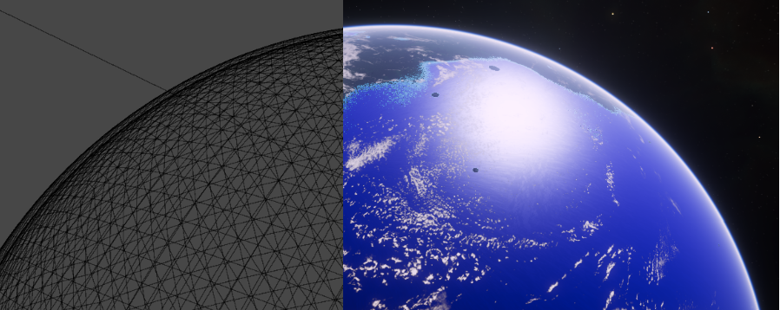

For the purpose of a transparent atmosphere, we do not need many of the features of the vertex shader like passing color values of the mesh or uv since there will be no textures or color assigned to the mesh. Only view direction and vertex position is utilized here. We utilize the fragment shader to perform all the necessary mathematical computations required for every pixel. This can be improved in the future by mirating this code to the vertex shader, since for objects close to the camera, there will always certainly be fewer vertices than pixels, leading to better performance. However this can be difficult to implement.

Scattering Functions

There are 2 main types of scattering effects that take place in real life and should be simulated. These are rayleigh scattering and Mie scattering.

By only enabling rayleigh scattering, we can see that this adds the effect of what we are all familiar with, blue skies. This is due to the scattering of blue light by particles like gas or water molecules, whereare’s other wavelengths are absorbed. The wavelength of light scattered can be defined in the shader inspector by a color picker.

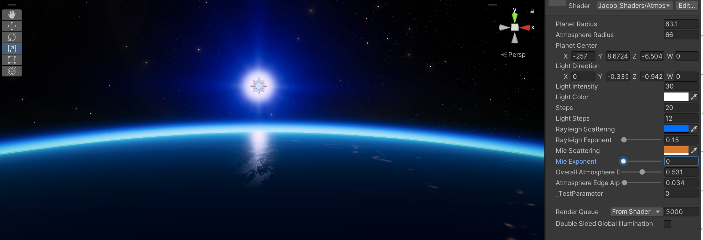

By only enabling Mie scattering we can see that mostly white light is scattered, and the amount of light scattered depends on the direction of the incoming light from each particle. Mie scattering is primarily caused by larger particles like aerosols in the lower atmosphere.

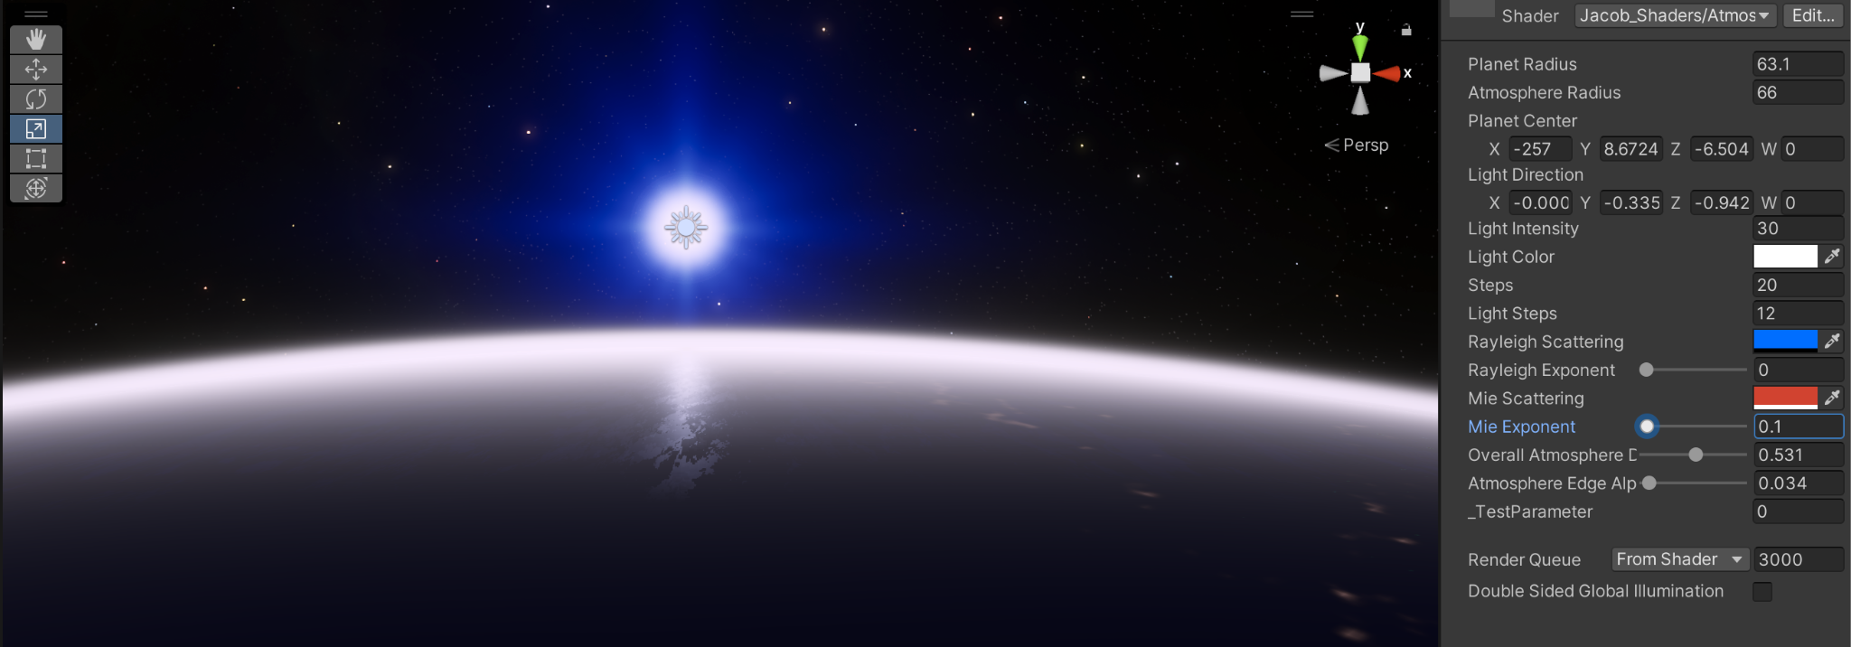

Rayleigh + Mie scattering
Blending of both rayleigh and Mie results in the upper atmosphere being blueish while the lower thicker atmosphere scattering more white / yellow or red light depending on the position of the camera and sun.

The 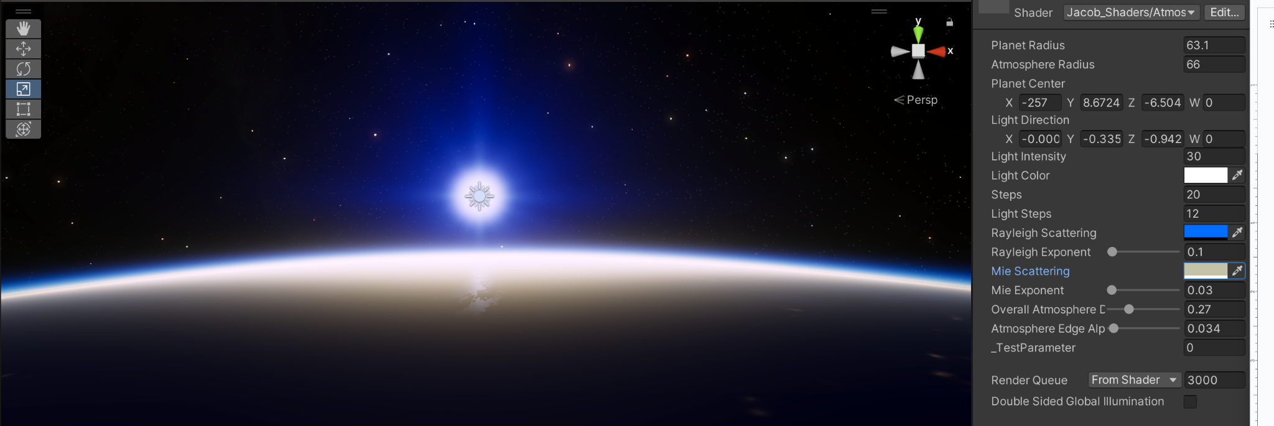Math of Atmospheric scattering
In Fragment shader

Step 1 : RaySphere Intersection

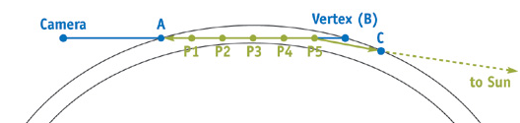
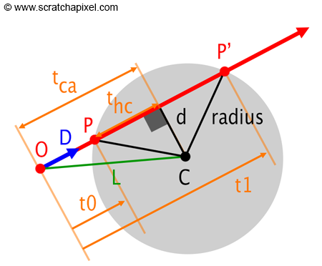
The first step is to determine the optical depth of each pixel. Optical depth is represented as the distance a ray travels within the atmosphere, in the case of an atmosphere the optical depth is point A to Point B from a view direction as mentioned in the vertex shader. To calculate the optical depth, this can be done with pre-built libraries that are available online that utilize trigonometry given center point C which is the center of the planet in clip space and clip space position.

Part of the sphere intersection function, which returns the position of first intersection t0 and second intersection t1

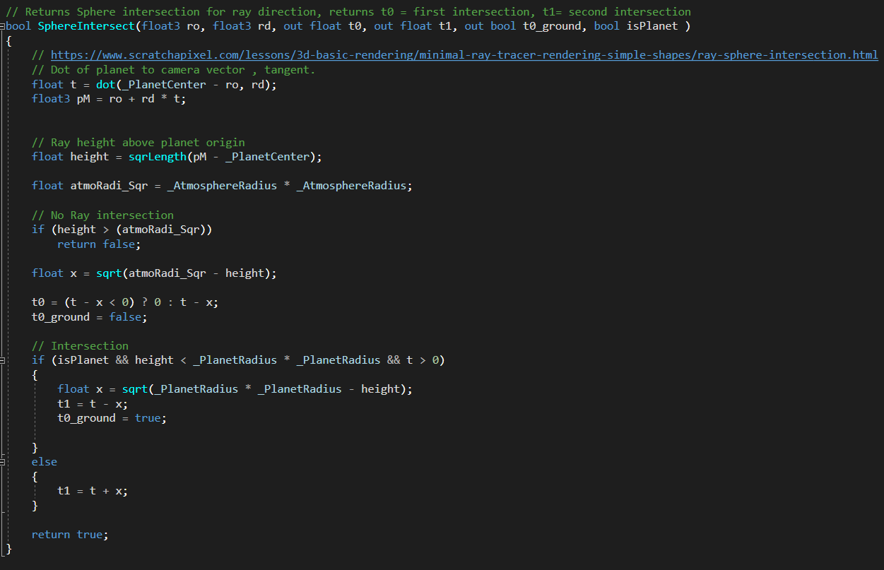

Step 2 : Define the Phase function
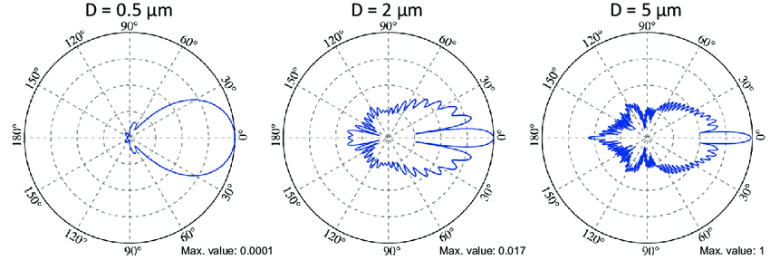
In the real world, when light hits a particle, some of the light is absorbed while others are scattered out. However the amount of light scattered out is not consistent. On the right a Mie scattering phase function indicates that more light is scattered aft of the particle than is scattered forward. Therefore the amount of light scattered with respect to the angle from the incoming light source (Sun) depends on the phase function. In the shader the phase function is used to calculate how much light is scattered for each light step point given the angle of the sun and the angle of the view direction or camera. E.g if the camera is directly opposite the sun, then the phase function indicates that the scattering intensity will be the brightest.

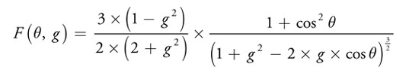
The phase function where:

f() is the result of the function f() is the intensity of light scattered.

theta is the angle of the view direction from the particle or light step point to the camera.

g is the scattering coefficient typically -0.75 to -0.999 for Mie. We use zero for g for rayleigh, so light just passes through the atmosphere and becomes blue as an approximation.

Actual code modified with reference : https://ebruneton.github.io/precomputed_atmospheric_scattering/atmosphere/functions.glsl.html

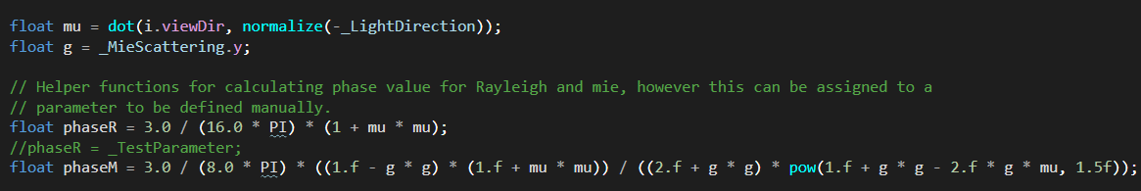

Step 3: Light March
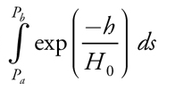
Given the user input of the number of light steps in the inspector, which determines the number of points, we can determine where each light march point will be located. This is later used to calculate the out scattering function.

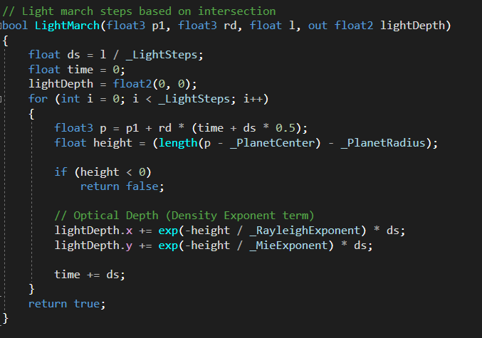

Distance of each point is the same and is simply the optical depth divided by the number of steps. Each point , p1, p2, pn can be calculated as a result by adding a distance vector. For each step, the density is sampled by taking h height and a manual input density exponent or falloff. If the exponent is 0.25 then the average density is at an altitude of 25% from ground to space.

Step 4: in / out Scattering Function

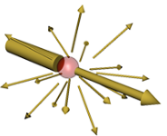
The out scattering function determines how much light is scattered for each pixel. The integral term on the right is already calculated above in the light march step as light depth (optical depth).
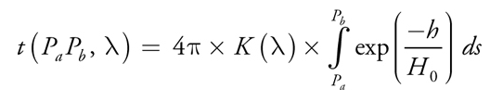

In code, rayleigh (left Term) and Mie (Right Term) are combined to obtain tau.

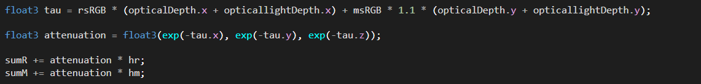

In scattering or attenuation, calculates energy added due to light from the sun for instance. We can simplify the formula where the attenuation is simply the exponent of tau and integrated with respect to ds (light step size)

In code we just need to take the exponent of out scattering to obtain attenuation.

Step 5: Output

Color of each pixel due to Rayleigh and Mie combined into RGB value and passed into the fragmentation shader. An alpha cutoff based on the atmospheric height blends the top of the atmosphere with the dark space.

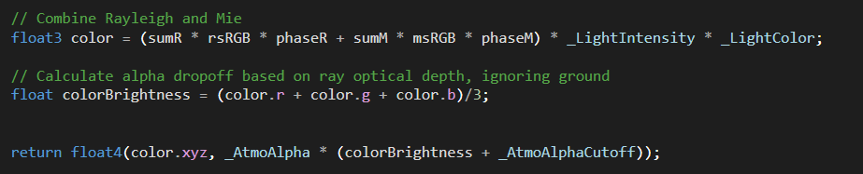

Step 6: Atmosphere dynamic properties (atmosphere.cs)
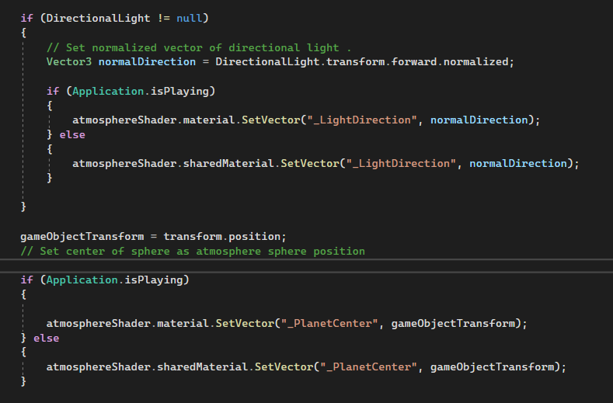
In the sphere intersection process, we utilized the central position of the planet as a centerpoint of the sphere intersection. Additionally other properties like sun direction changes with respect to time. In order to keep these properties updated, we created a script that targets those properties and dates it.

In application play mode, the shared material reference is used while for build, material reference is used.

Math and Physics - Ship Module
By Jacob Tang

The ship module is responsible for all ships' players and enemies, which are rendered in its own scene, where the player’s ship is in a floating origin position. Once again to overcome the precision issue in unity.

Component | Key Function | Source (Exclude dependencies)
Inertia Tensor | - Tensor component that governs how spacecraft reacts to external forces.  - Ability to add forces to spacecraft  - Handles spacecraft local movement and rotation | - InertiaTensor.cs
Ship Controller | - Coverts user input to thruster commands. | - Spaceship.cs  - PIDController.cs
Input System | - Handles user input | - ShipInput.cs

Spacecraft Axs
In space any spacecraft has 6 degrees of freedom, in 2 different modes, these modes are rotation axis,which is similar to what an airplane has (pitch , roll and yaw). Unlike aircraft which use rotation to control movement direction, spacecraft use dedicated thrusters to control movement. This is the translational mode.
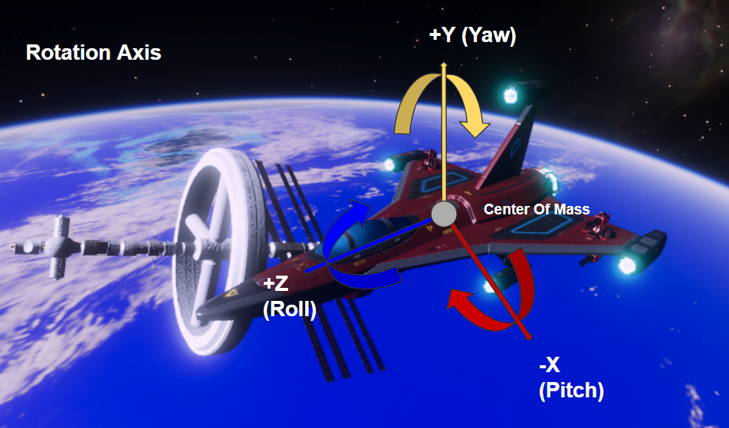
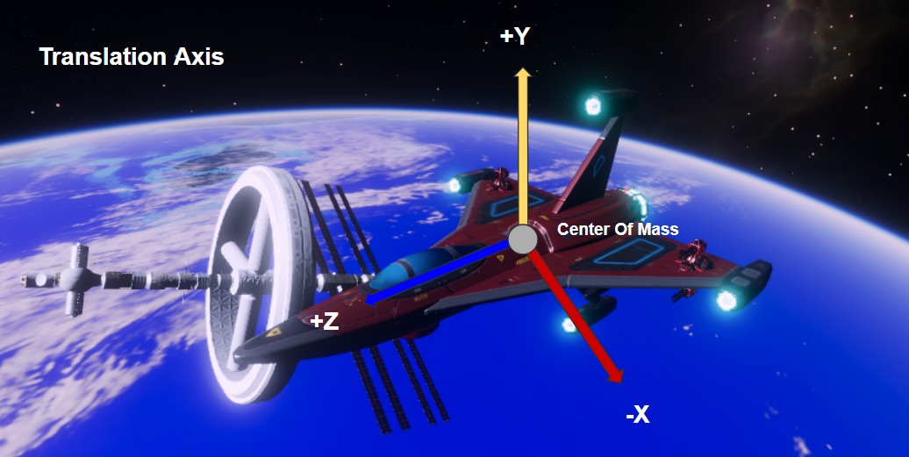

For each of the 6 axes of freedom, we chose to use unity’s strange axis (Z,Y,X) convention nevertheless as shown above.

Reaction Control

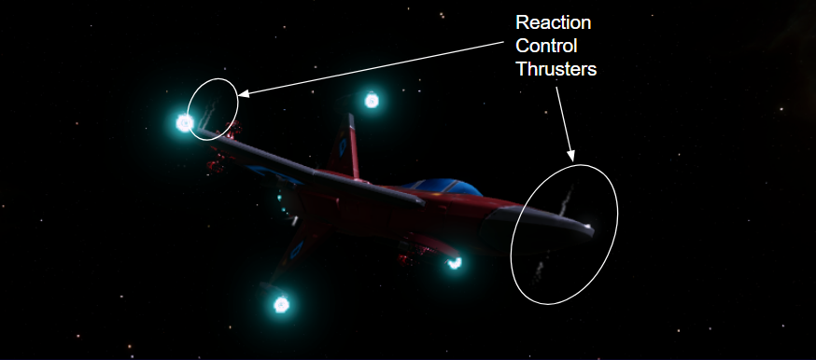

In space there’s no air or reaction mass to act upon. So spacecraft cannot use the same control surfaces like on an aircraft. Instead spacecraft use a reaction control method, where according to Newton's third law, every reaction has an opposite reaction, by shooting out puffs of gas at high speed or a reaction, the gas causes an equal and opposite reaction to the spacecraft. Control of the spacecraft in all 6 axes is achieved this way.

To determine how much a spacecraft moves when a reaction force is applied, we first need to compute the inertia of the spacecraft. There are two modes of inertia, rotational inertia and translational inertia. Rotational inertia is the resistance of the spacecraft that prevents the spacecraft from rotating, this rotational inertia is proportional to the size of the spacecraft as well as the weight distribution of the spacecraft. I.e if the spacecraft is long, then on the long axes, the spacecraft has a higher inertia. Next there’s the translational inertia, this inertia is the spacecraft’s resistance from moving in the translational mode, where the spacecraft can be treated as a point mass about the spacecraft’s center of mass.

Inertia Tensor - Rotation

In order to efficiently calculate the resultant rate of rotation, we implemented a tensor of inertia of rank 2. First let's consider the moment of inertia of a simple cube about the cubes center of mass in each of the 3 axis:

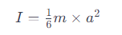
Where:
I is the moment of inertia (kg.m^2)
M is the mass of the cube
A is the length of cube side

Suppose we want to calculate the composite inertia of an irregular shape like a spacecraft, then we might be able to approximate the number of certain size cubes that we can fit in the spacecraft’s volume and sum up its moments of inertia, to obtain a composite moment of inertia.
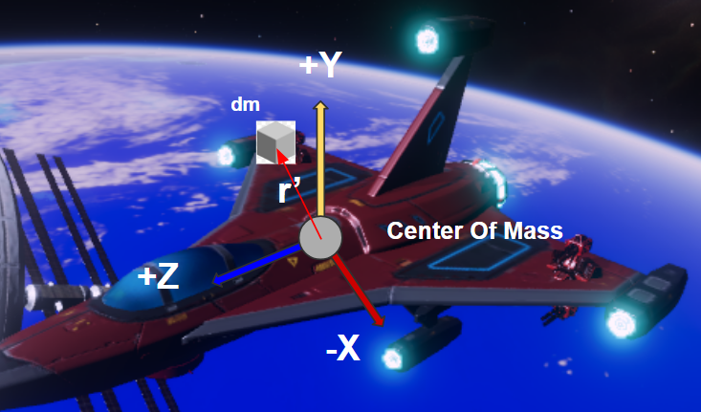
First consider the example on the right, the right most engine pod’s mass is represented by the cube. When the engine pod is attached to the spacecraft, the center of mass for that pod is now the center of mass of the composite spacecraft and the engine pod’s mass is just part of the spacecraft’s total mass. The pod’s mass can be denoted as dm (small mass).

For each point mass (box) its angular momentum can be defined by expending the inertia equation and converting it to the equation shown below.

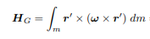
Where:
H_g is the angular momentum about point G or the center of mass
Ω is the rotational rotation or angular velocity
r’ is the distance of the center of that cube to center of mass of spacecraft
dm is the mass of the cube

Next we can rewrite the equation for each of the 3 axes of freedom based on the center of mass of the spacecraft.

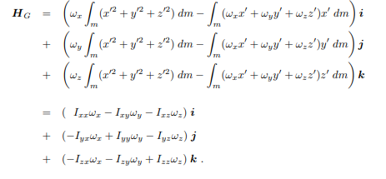
Where:
x , y, z are components of the distance vector r’.
I ,j ,k are unit vector components of the direction. The Sum of j + j + k is always = 1 for any rotation.

The moments of inertia with respect to x y and z axis for a cube about the spacecraft's center of mass can be expressed as moments of inertia in Ixx , Iyy and Izz components.

For the moment of inertia between axes like between x and y, we can use the convention Ixy etc.. This accounts for how mass is distributed about about x and y axis simultaneously.

Then we can substitute this to the previous equation to obtain Hg where the moments of inertia about the ass axis can be calculated given i j k components of the direction unit vector. H_g =

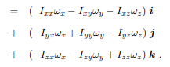

We can extract the angular velocity from the above and write it in tensor form.

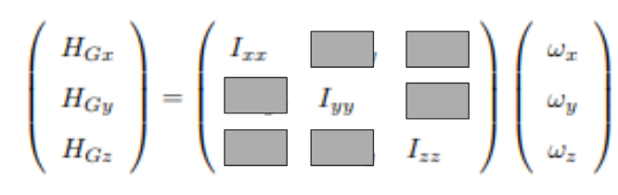

Where:
Hg.. is the angular momentum
Ixx … is the moment of inertia about each axis and the intermediate axis
Ω is the rotational rotation or angular velocity

For our application in unity, we can simplify it to not account for the intermediate axis and just use the principal axis inertia tensor. This simplification is a good tradeoff between realism but faster development cycle as we can integrate with unity’s rigidbody system.

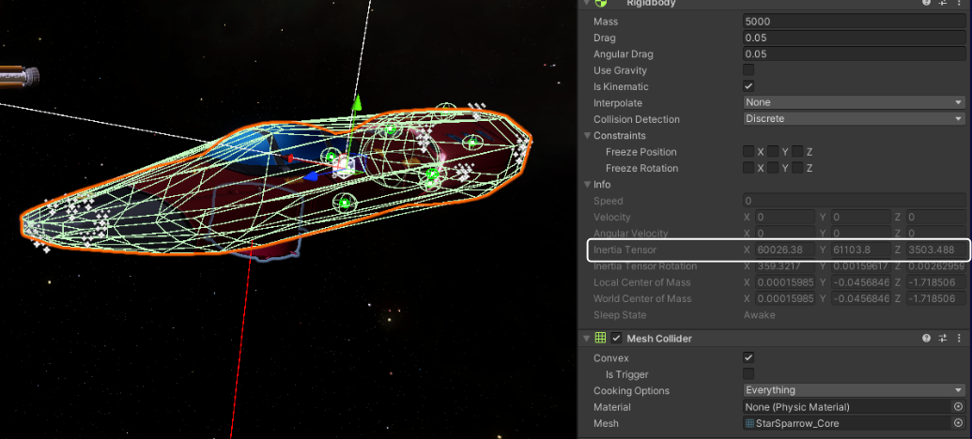

In Unity, if we attach a rigidbody to an object, unity utilizes the collider, and its mass to calculate the inertia tensor. The mesh collider is a good approximation of the actual shape of the object, as shown above the simplified cockpit section. The convex mesh is then used to calculate the composite inertia tensor under the hood by breaking the mesh into cubes or other primitive shapes, then integrating it using the principal axis theorem to obtain a composite inertia tensor. However unity does not expose code for this process. If we would like to have a spacecraft that is in the mode of different modular parts, and each modular part is a rigidbody, there is no way with unity’s default rigidbody to produce a composite inertia tensor and center of mass by combining all several rigidbodies together. Hence we need to reproduce this system under the hood ourselves so the computation can be done to obtain a composite inertia tensor.

Composite center of mass
The first step is to obtain the spacecraft composite center of mass, which depends on how mass is distributed across the spacecraft modules. Each module has its own mass and center of mass. The composite center of mass about each axis can be derived from the equation below

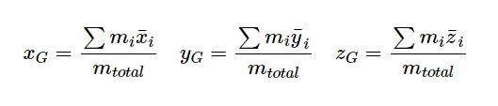
Where:
X Y and Z are distances from a common reference point, this would be geometric center of the command module section (transform.position)
X Y Z Bar is the center of mass of each module about that common reference point
M is the mass.

Using a recursion search we can find out all child modules attached to the command module, and by summing up all centers of mass for each module, we can obtain the composite center of mass as shown below.

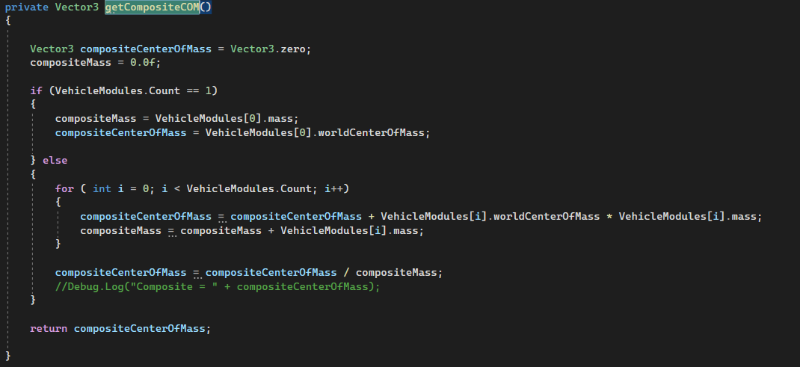

Composite Inertia Tensor

To obtain the composite inertia tensor of the spacecraft, we first need to find the individual inertia tensor for each module. Then the parallel axis theorem can be used to sum up the tensors for a composite tensor. It states that if the inertia tensor is known relative to a center of mass, then the inertia can be calculated about a new abratory point, which could be the center of mass of the player ship instead. This can be achieved using the inertia tensor generalization of the parallel axis theorem.

Where:
J is the inertia tensor calculated about that new abratory point
I is the inertia tensor calculated by unity’s rigidbody about the modules own center of mass
R is the displacement or offset vector from the module’s center of mass to the ship's composite center of mass.
E is the identity matrix
X is the outer product
M is the mass of the specific module

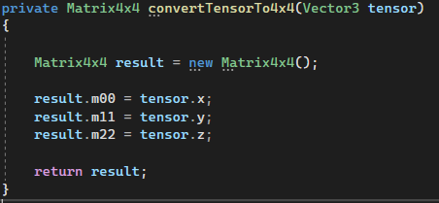
In unity, the inertia tensor is represented in the vector form which represents the diagonal inertia matrix, we need to convert the vector form tensor to a 3x3 matrix, however since unity only has 4x4 matrix, we add in a additional column that is equal to zero. m00, m11 and m22 are the diagonal components of the matrix.

Additionally unity’s matrix 4x4 only supports matrix to vector operations, matrix to matrix operations lille addition, multiplication and the inverse of matrix is not supported. Some custom effort is put into adding these operations in order to assist in the computation.

On the (left) implements the matrix to matrix addition, subtraction, and multiplication.
On the (middle) implements the inverse of a matrix.
On the (right) implements the outer product of a vector.
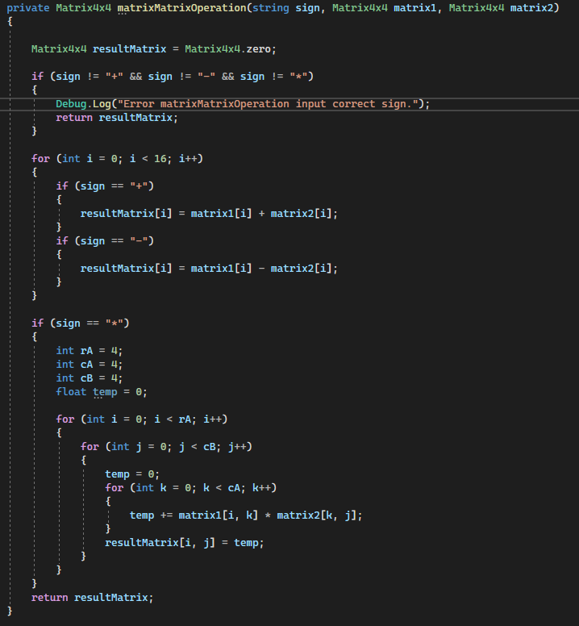
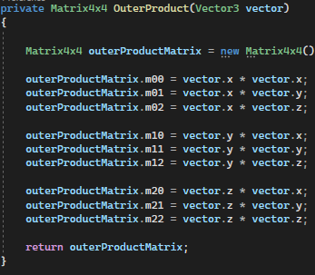
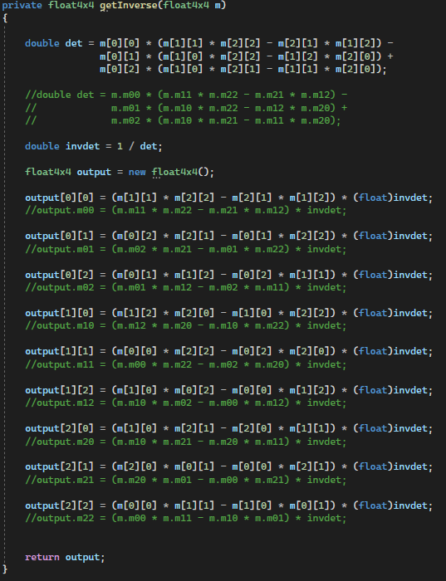

By iterating through each attached module of the spacecraft, we can calculate the composite inertia tensor. Notice that for the offset vector we need to transform the world center of mass of the module to the world center of mass of the ship to the local frame of reference of the parent object.
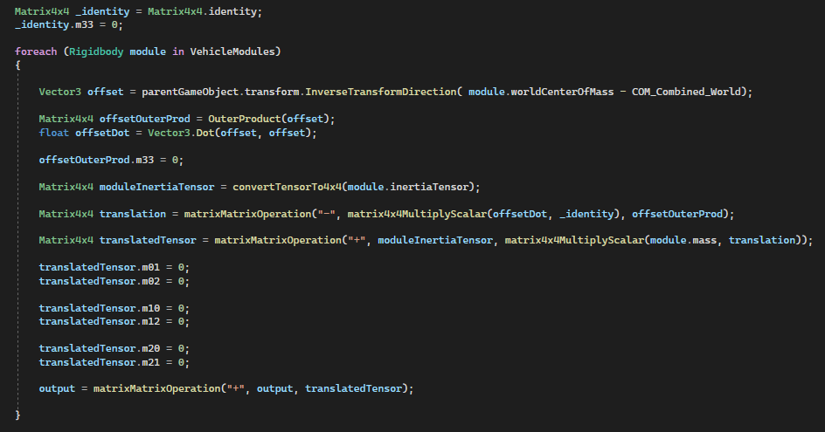

Torque

Using the relationship below:

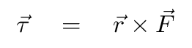
Where:
Tau is the torque vector x, y, z relative to local axis of the command module
R is the displacement vector relative to the composite center of mass of the ship
force is the negative of the thrust (since the reaction force on the spacecraft is opposite of the thrusting direction)
X is the cross product.

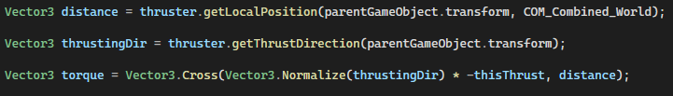
To calculate how that torque affects the spaceship in terms of changing its angular using the following formula earlier, where Hg is the angular momentum,

We can replace angular momentum with torque and multiplied by inverse of inertia tensor to obtain angular acceleration, or delta Omega. Delta omega will be the acceleration to angular velocity caused by the application of a force vector, for instance a thruster over time.

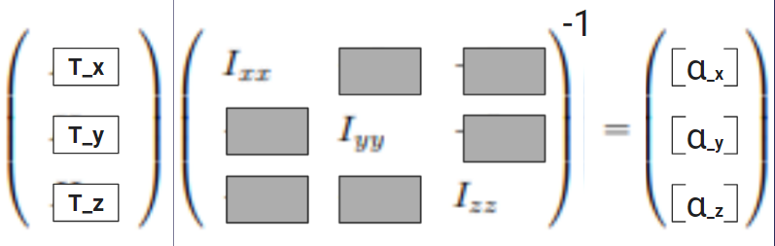

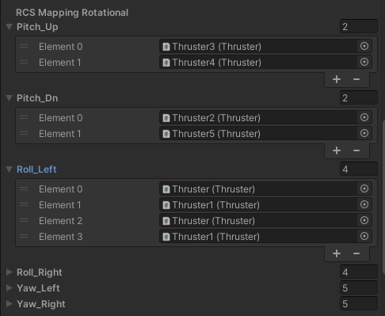
When the delta omega value in the local playership frame can be then used to calculate which thrusters must fire for each of the rotational axis. The largest component of delta omega means that force is most efficiently translated to that rotational axis . Thruster mapping for each axis can be determined.

Translational movement

Translational movement can be easily calculated given that we treat the playership composite as a point mass. Then the translational movement would simply be the sum of all forces using the vector form of F = M.a.

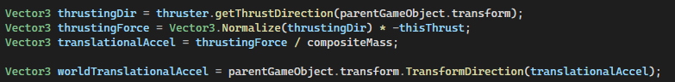

Once again we can use the same code above to determine which thruster is most effective in which translational axis, this is then used to update the translational RCS mapping shown below.

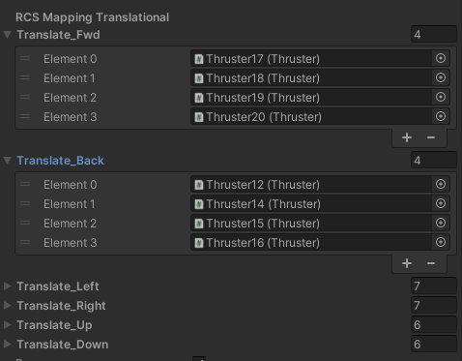.

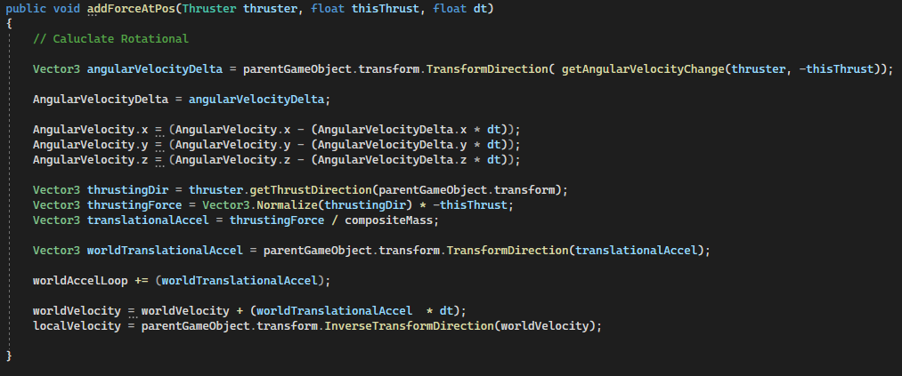
The inertia tensor implements a add force at position function, this is similar to the rigid body add force function that comes pre built into unity’s rigidbody’s system, however this function adds forces based on the composite inertia tensor as well as the composite center of mass. Both rotational acceleration translational acceleration is calculated for each time step or delta time.

Handling of position and rotation of gameobject

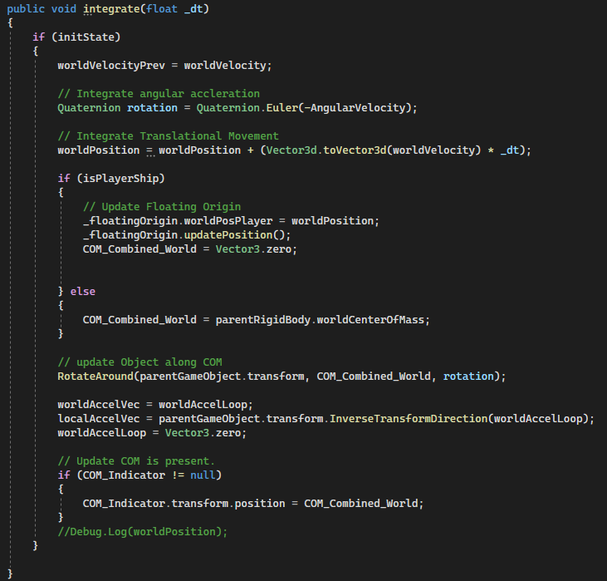
All motion of gameobject is handled by the inertia tensor script. With the script, word position, world velocity are stored in double precision format and run continuously in each fixed update. When another function calls the add force at the position function, the function updates the angular acceleration and acceleration.

For each fixed update cycle, multiple add force at position can be called and it simply adds up all the acceleration. In each inertia tensor fixed update, the acceleration is integrated and added to the world position and world velocity. Note that this world position and world velocity is always the floating origin position, where its initial value is zero. The player’s displacement from origin is calculated and applied to all other ship objects in the scene to transform them to the player's frame, allowing the player ship to be always in game origin. The player’s position and velocity in the planetarium is stored in the orbit.cs heliocentric position and heliocentric velocity.

Spacecraft Input

Spacecraft Control

To Be Continued ……

Crafting Dynamic Spaceships and Paths
This section outlines my involvement in the development of the modular system and pathfinding logic for 'Endangered Orbits'. It details my efforts in creating a dynamic ship customization experience and implementing navigational intelligence within the game's environment.
Modular Ship Construction
The Goal
To illustrate the goal of the modular system I am going to share some gameplay of the game that inspired it:Captain Forever Trilogy Gameplay. The steam page for the game describes it as such:
“In Captain Forever you build spaceships while you are flying them. There's no cumbersome editor. Just blast an enemy ship apart, grab a piece with your mouse, and bolt it to your ship. Done. What's more, everything is physically simulated so ship design has a huge impact on flight characteristics and combat capability.”

This basically encapsulates the goal that was aimed for in Endangered Orbits. However, while Captain Forever is a 2d game, Endangered Orbits is in 3d and this brought up new issues to solve.
Defining Modules
To create the basic building blocks of the ship - the modules - I created an interface structure that made use of inheritance. The root interface for this is called IModule, which serves as the foundation for all module types in 'Endangered Orbits'. This interface ensures that every module within the game adheres to a uniform set of properties and behaviors, creating a consistent and extensible framework for module development. Within this interface, several key elements are outlined.
In the subsequent description of the interfaces, I outline the intended functions as dictated by the interfaces. However, since an interface does not inherently express these implementation intentions, we adopted a traditional class hierarchy to actualize the interfaces. Our game modules then inherited from these classes. This was done primarily to prevent the need to duplicate code across several classes.You could argue that this makes the interfaces redundant.
public interface IModule
{
public GameObject GetGameObject { get; }
public string Name { get; set; }
public int Health { get; set; }
public int MaxHealth { get; }
public int Mass { get; get; }
public DamageResistancePercent DamageResistance { get; set; }
public List<IAttachable> AttachedModules { get; set; }
}

Most of these properties, like “health” are straightforward in their purpose and so I will skip describing them. The two properties that require a more in depth description are AttachedModules and DamageResistance .
AttachedModules is simply a list of modules that are attached to this module. As will be shown later - each module may have many attachment points. This list contains a reference to any modules that may occupy and such points. This implicitly creates a tree structure where each ‘node’ may have a number of child ‘nodes’ equal to the number of attachment points the module has. This list is primarily a convenience. All child modules are set as children to the parent module via the game object. You can use transform.GetChild(int index) to access the children of any module - but you would have to loop through all children and filter out unrelated game objects. In all cases the parent is accessed via transform.parent.
DamageResistance is an instance of the class DamageResistancePercent. This class simply exists to store a float but limit it to between 0 and 1 - thus representing a percent.

public interface IAttachable : IModule
{
public bool IsAttached { get; }
public void Attach(AttachmentPoint attachmentPoint);
public void Eject();
public void Disconnect(bool removeFromList = true);
public void PickUp();
public void Release(Vector3 releaseVelocity);
public AttachmentPoint FindThisConnectionPoint();
}

IAttachable is the other interface that needs to exist to structure the module system. As you can see it inherits IModule. This interface simply enforces the inclusion of functionality that allows a module to attach to another module. The only state required here is a flag to denote whether the module is attached to something or not.
Here is a quick description of the purpose of the functions:
- Attach
This function attempted to join two modules together in this way:
  - Align the current module's game object with the game object of the target attachment point.
  - Set the current module's game object as a child of the parent module's game object. The parent module's game object is retrieved from the target attachment point.
  - Change the current module's game object rigidbody to kinematic.
  - Set the attachment flag to true.
- Eject
This function launches the module away from what it is connected to. Here is how:
  - Unset the current module's game object as a child of the parent module's game object.
  - Change the current module's game object rigidbody to dynamic.
  - Set the attachment flag to false.
  - Apply a force to the current module's game object to push it away from the parent module.
  - Get the player ship's current vector and slowly apply it to the current module's game object to halt its movement relative to the player ship.
The reason we slow it down in 2.5 is so that modules don't fly off into space and thus prevent the player from acquiring the module for their own ship. This function is never invoked directly by the player’s actions but rather is triggered when the module can not validly be connected to its parent anymore. This can happen, for one example, if the parent module is destroyed in combat.
- Disconnect
This function simply severs the connection between two modules. Here is how:
  - Unset the current module's game object as a child of the parent module's game object.
  - Disable the rigidbody interactions of the current module's game object.
  - Set the attachment flag to false.
The rigidbody interactions are disabled to ensure the module, post-disconnection, does not collide with other objects while being constrained to the player's mouse cursor. This ensures that the player cannot use the module to interact physically with the environment or other objects.
- PickUp
This function simply makes the necessary changes to the module, like disabling the rigidbody, to prepare a module to be constrained to the player’s mouse
- Release
Reverts the module to its original state after being picked up by the player and applies a velocity to the module in proportion to the player’s mouse movement, but with a velocity maximum.
- FindThisConnectionPoint
Returns the first found attachment point on the current module with ConnectionPoint set to true. See the section on AttachmentPoint to understand this.

When two modules are joined together they are kept together because the child game object is a child of the parent game object. Setting the rigidbody to kinematic keeps the child in the position it is supposed to be at.
Attachment Points
Attachment Points are basically game objects that are positioned at the point on a module where you want it to be able to attach to other modules. These are controlled via the AttachmentPoint class. The control this class manages is two things
- Based on the position and rotation of the game object - how to attach other modules to the given point.
- Enabling and disabling the mesh render at appropriate times.
  - This also includes systems that allow the material(s) used to be changed in runtime.
In order for modules to be attached to each other, the AttachmentPoint class enables
precise alignment based on the position and rotation of the game object that the AttachmentPoint instance is attached to. When the Attach() function is called, it uses an AttachmentPoint instance to determine how another module should be aligned and connected. The process involves aligning the forward | 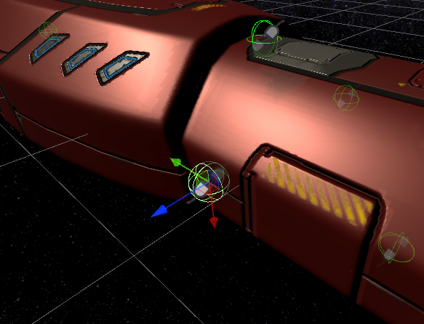  An attachment point in the editor. Note the forward vector.
vectors of the connecting points using quaternion rotations, ensuring that the module is oriented correctly with respect to the target attachment point.The function also adjusts the Z-axis rotation to match that of the attachment point, maintaining consistency in the orientation. Additionally, it calculates the necessary translation to position the module exactly at the attachment point. Once positioned and rotated correctly, the module's GameObject is set as a child of the attachment point's parent GameObject, ensuring it moves and behaves as a unified object.
Finally, the attachment points on both the attaching module and the target module are marked as occupied, and their visual meshes are hidden, indicating that a successful connection has been made.
In order to determine the AttachmentPoint that should be used to make the connection on the module that the player is holding, each one has a bool named connectionPoint. When the attachment process is invoked on the module the player is holding a linear search is performed on the module’s children. When the first AttachmentPoint with this value set to true is found - it is that point which is joined as described above.
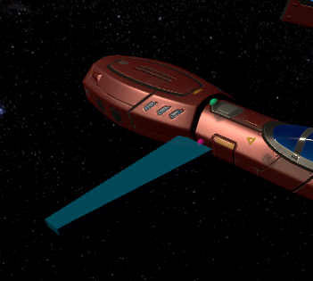
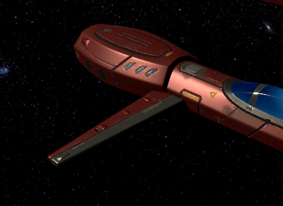
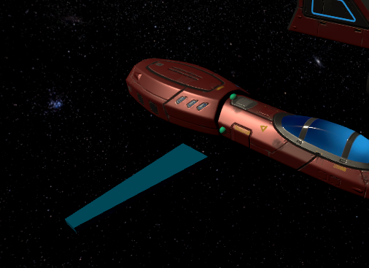
Left Image: holding an object; the attachment points now highlight green.
Center Image: the hovered attachment point is now pink and the module floats above it.
Right Image: the module is now attached; the attachment points are now hidden.
Control
In Captain Forever, the developer used a 2D world and so when the player held a module, there were no problems to solve. In the 3D world space of Endangered Orbits we now suddenly have to worry about how far the mouse is away from the camera, about the occlusion of attachment points, about the difficulty of controlling a ship with 6 degrees of freedom (which means movement can occur in all directions) while also building it. Some compromises were necessary, and it's fair to say that the experience of slapping some modules together and sending it is not as streamlined as in the case of Captain Forever.
The first problem that needed to be solved was where to float a module while the player was holding it. The most user-friendly solution is to hold the object the same distance away from the camera that the core of the ship is. To achieve this a script is attached to the main camera. In this a plane called the InteractionPlane is created. We use the camera's forward vector to align the plane in the correct position and then place the center of the plane at the core of the ship by getting the position property of its transform. When the loop that updates the position of a held module runs it finds the point on the plane it should reposition the module to by using ScreenPointToRay on the main camera. This finds the distance of the plane from the camera and allows the accurate positioning of the module.
When the player is holding a module it enables an if clause in the Update function on the interaction controller (where all the input control is located) This where the function that updates the position of the held module is called. This also calls a function that checks for the player hovering over an attachment point. By placing the attachment points in their own layer we can use a layer mask to get only the attachment points from a ray cast. When the player is hovering over an attachment point the module is positioned over the prospective attachment area - but with an offset so it looks like it is hovering over the point. The occlusion problem is sufficiently dealt with by simply selecting the 1st attachment point that the ray cast hits.
Finally the problem of dealing with flying the ship while building it in a full newtonian simulation is really only solvable through player skill. It also would likely require additional controllers, such as a joystick - because otherwise the mouse becomes overloaded with responsibilities. We settled on having three modes. First there is a build mode which allows the addition and removal of modules from the ship. There is a camera mode - which is the same as the build mode except you can't modify your ship. Finally there is a combat mode. In this mode the ship attempts to orient in the direction you are looking and the controls for lateral movement control are activated.
Pathfinding
In the game "Endangered Orbits," players move through an environment that is quite different from typical games. This environment doesn't have a traditional "ground" for characters to walk on, making standard pathfinding systems, like the one provided in Unity, unsuitable. Since there's no ground in "Endangered Orbits," there is no surface with which to make a map of ‘walkable’ areas. The concept of a nav mesh does not apply in space.
One possible solution to this problem is to use an "octree." An octree is a type of data structure that can efficiently represent three-dimensional space. It could potentially provide the necessary framework to apply algorithms like Dijkstra or A* for pathfinding in a three-dimensional space. However, we didn't use this method. Unity's built-in pathfinder, which is designed for more traditional game environments, doesn't support the use of octrees directly. Therefore if we wanted to use an octree we would have to develop our own pathfinder. However, an octree pathfinding implementation would be absolutely overkill for this game.To quote WALL-E: “There's a lot of space in space.” It is possible to handle 99% of situations with a far more rudimentary algorithm.
It’s Raycasts All the Way Down.
Since obstacles will be both rare and convex in most situations there is no need for an advanced pathfinder. All we need to do is shoot a raycast at the destination and if there is no obstacle found we just go for it. In the case that there is an obstacle all we need to do is use the obstacle’s bounding box to plot an intermediate point to fly to first.
The process starts by determining the diameter of a sphere based on the object's speed and a base diameter value. This sphere represents the “safety” space in which the vessel would like there to be no other objects. The script then uses the calculated size in a sphere cast projected from the object's current position towards its destination. This effectively checks for any obstacles along the way.
If this sphere cast detects no obstacles, or if an obstacle is near enough to the destination that it wouldn't be an obstacle, the script concludes that a direct path is possible and sets the path accordingly. However, if there's an obstacle blocking the direct path, the script initiates a process to navigate around it.
First we store the original destination as the final destination, then we analyze the obstacle's size and position by examining its bounding box. To calculate the most efficient direction to detour around the obstacle, we find the smallest dimension of the obstacle's bounding box. It could be either to the side, upwards, or forwards relative to the object's current orientation. Once the shortest direction is determined, we set a point on that side of the object with an offset about equal to the diameter calculated earlier. This point is the new movement destination is effectively an intermediate step to the final destination.
Each intermediate position undergoes the same verification as the original destination did. Because of this it is necessary to implement a step counter and check against a maximum number of allowed steps for pathfinding. This is to avoid getting stuck in an infinite loop of calculating intermediate points if the path to the destination remains consistently blocked. If the number of pathfinding steps exceeds this maximum limit, the script calls upon an alternative method.
The alternative method of choice for us is called the Tangent Bug Algorithm. The core concept of the Tangent Bug Algorithm lies in its ability to balance between local and global path planning strategies. It operates by first detecting the nearest obstacle in the path of the moving object. Unlike simple raycasting, which only checks for direct obstructions, Tangent Bug considers the shape and orientation of obstacles to find the best possible way around them. Once an obstacle is detected, the algorithm calculates 'tangents' or points on the obstacle's boundary that are visible from the object's current position. These points serve as potential waypoints for navigating around the obstacle. The algorithm evaluates these tangents to determine which one offers the most efficient path towards the goal while minimizing the detour distance. After selecting the most suitable tangent point, the algorithm guides the moving object towards this point. Upon reaching it, the Tangent Bug reassesses the environment, checking for new obstacles or changes in the surroundings. This process of moving from tangent to tangent continues until the object either reaches its destination or identifies that no viable path is available.
Unfortunately we never had the time to implement this. The environments in the game meant that this would largely be a novelty and it would rarely be needed or get used. Consequently we could not spare any of our development time to it and so when the basic pathfinding fails it just hits a placeholder function and gives up.
Object Avoidance
The one other thing implemented for NPC movement was a series of simple object avoidance algorithms. These can be itemized as such:
(Note that “our” is referring to an instance of an NPC going forward here)
- Maintain a safe buffer in the immediate vicinity, thus avoiding nearby objects.
- Monitor objects in a particular layer and avoid them if a collision seems likely.
- Use our current velocity to project if we are going to collide with something and attempt to avoid it.
Each of these is run once every update.
To perform the close avoidance check we start by running an overlap sphere on our current position. After filtering ourself out of it we look at the remaining objects if any. For each of those objects we get their relative velocity to ourself. Using our velocity vector and the relative velocity vector we get an angle. If the angle is greater than or equal to 90 the object is moving parallel or away from us and can be ignored. If it is moving to us we divide the angle by 90 and then invert it to get a value between 0 and 1 that represents how directly it is coming at us. Then we divide the magnitude of that object's vector with the size of the overlap sphere and invert it to get a value between 0 and 1 that represents how close the object is. Finally - assuming that we are on collision courses even if we are not - we calculate a time to impact. If the impact is greater than 10 seconds we ignore the object for this cycle of avoidance. Otherwise we fly away from the object by requiring a velocity that would allow us to avoid a collision. This calculated value is multiplied by the angle and distance calculation we did earlier to make us more responsive to closer things that are coming directly at us. Finally the calculated velocity we want to request is placed into a variable store in the class context to be acted upon in the next FixedUpdate.
The avoidance check for things in a particular layer is very similar. This step came about because the original test of just firing sphere casts in all directions left too many holes in vision. Rather than do the intensive process of scanning everything in a 360 sphere, I thought it better to just directly check the things that can move as there will never be more than about 10 of them. You could define this as the computer cheating since it technically always knows where you are in order to perform this calculation, but the decision processor for the NPC does not use this information. When this step occurs, rather than detect objects with an overlap sphere or sphere cast, we simply collect all the objects in the specified layer into a list and iterate through it. The angle and velocity checks are much the same. The primary difference is that rather than running directly away we introduce a lateral move to perform a dodgeding motion. This is done because we have a limited amount of acceleration and if the object is flying in at us from a kilometer away it will be moving far faster than we can accelerate to in time. To generate the lateral movement we take the vector to the object and make a copy. In this copy we swap the sign of one of the components. Then we take the original vector and the modified copy and get a cross product. This gives us a perpendicular vector. Then we simply request maximum acceleration in this vector. This request is stored in the same class context vector as described in the previous section.
The final check is the “don't run into stuff” check. In this check, we simply take our current vector and plot where we would be in 10 seconds if we continued at a constant velocity. Then we fire a sphere cast to the position. If we find anything from the sphere cast, we calculate the nearest point of impact on the obstacle using the hit point and the normal of the hit surface. We enlarge this point by half of our sphere's diameter to ensure we're not just avoiding a collision, but also maintaining a safe distance from the obstacle. Then we calculate a perpendicular vector just like in the prior step. However we take an additional step this time. In order to try and find the most empty direction to move in, we iterate through a series of such vectors by rotating the original calculated vector in 10-degree increments. For every generated perpendicular vector, we assess a point in the direction of that vector, at a distance equal to the projected 10-second travel distance. We check for obstacles at that point using a small-radius sphere overlap test to calculate the shortest distance from the center of this sphere to the nearest surface of any obstacle encountered. This distance serves as an indicator of how 'safe' or 'clear' that direction is. The vector associated with the greatest distance from obstacles is deemed the safest. This vector represents the direction in which we can move to maximize our distance from potential hazards. To evade the obstacle, we calculate the necessary acceleration based on the distance to the nearest obstacle boundary and our current speed. We set the evasion velocity as this acceleration multiplied by the safest perpendicular vector. This vector is added to the same context variable as the other two steps.
Movement
All movement, both for avoidance and pathfinding, is performed in FixedUpdate. This is why all of these steps pool the velocities they calculate into a single, accumulated movement direction. In the avoidance function, velocities that have no hope of being attained are often requested. Because the magnitude is based on need, when the pooled vector is normalized only the most important action survives. This also prevents the various steps from fighting each other and creating chaotic movement patterns. The actual movement is delegated to a movement controller. This decouples the actual movement from the method so that these calculations can still be used regardless of whether we are using the humble addForce or a more complicated system. For more about how ships move in the game refer to Jacob’s section above my own. Because all of the vectors are pooled into this single request, the avoidance systems can freely interrupt pathing as necessary and after the threat has passed it will simply resume. The use of a single pooled value means that this occurs with no explicit effort to make it so.
The other task that is completed in the FixedUpdate is managing the life cycle of the pooled vector. This involves a set of counters that track different aspects of movement and evasion. For instance, an evadeResetUpdateCounter is incremented whenever the NPC has not detected anything, indicating a period of non-evasive movement. An evadingCounter increases whenever there is a need to evade. The prior is used to determine when the pooled velocity should be cleared so that the ship eventually stops moving. The latter is used to inform the close evade function. Recall that it tries to fly directly away from the other object. When this count gets large enough it will instead use a perpendicular vector like the other functions.

